DigI – VET
FOSTERING DIGITISATION AND INDUSTRY 4.0 IN VOCATIONAL EDUCATION AND TRAINING

Intellectual Output 4 – Teaching & Learning Material

Table of Contents
Module A 3
Digitisation 3
Industry 4.0 – An Introduction to the ideas and new possibilities 5
Module B 9
Importance of Digitisation. How does it affect the Education and Industry? 9
DigI-VET – Aims, Structure and Core Ideas 11
Module C 14
General Aspects of Digitisation at Industry 14

Module A
Digitisation Terms and history

Digitisation

Mainly when students are being asked what the digitisation is, the common answer is increased level of technologies. However, is it the only possible definition or are there any other elements contributing to digitisation?

Tasks:

- What are the 3 most essential factors defining the process of Digitisation? Contrast the the effect of digital transformation on technology and on people.
1.

2.

3.

Digital transformation on technology focuses on ……, meanwhile, digital transformation affects people by focusing on …… .

- Fill the chart.
Finish writing the definitions.
Digitisation is ….

Digitalisation is …

Digital transformation is …

- Read the following passage from the report published by UK government (https://publications.parliament.uk/pa/cm201719/cmselect/cmsctech/1455/1455.pdf ; accessed 9 June, 2020). Imagine you are being asked to draft the possible options to the government of how they could transform Government services. How would you come to this solution?
‘In 2018, the Organisation for Economic Co-operation and Development (OECD) emphasised the importance of Governments across the world harnessing digital technologies in order to adjust to the “changing expectations and needs” of modern societies. In practice, meaning that their services were digital by design, data-driven, user-driven and proactive in policy making.They set out the power of digital to transform Government services and to put the citizen at the heart of what the Government does:
This transformation requires governments to take a user-driven approach, empowering citizens and business to interact and collaborate with the public sector to determine and address their own needs.’

- In Government Transformation Strategy (2017),UK government set 3 goals and one of them is to transform ‘the relationship between citizens and the State - putting more power in the hands of citizens and being more responsive to their needs.‘
What is the importance of developing the relationship between the citizens and the State? How could citizens have more power?
The importance of relationship between the citizens and the State is …..

Citizens could have more power in their hands if the government ….

Industry 4.0 – An Introduction to the ideas and new possibilities

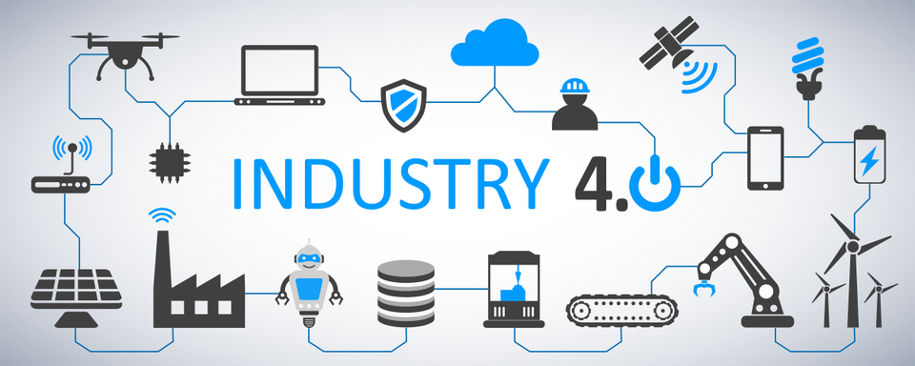
https://www.forbes.com/sites/bernardmarr/2018/09/02/what-is-industry-4-0-heres-a-super-easy-explanation-for-anyone/ (Accessed 17 June 2020)
The current passage and image is taken from an online source and provides definition of Industry 4.0 and Internet of Things. Use it to complete the following tasks.
(https://www.i-scoop.eu/industry-4-0/ accessed 16 June 2020)
‘Industry 4.0 is the digital transformation of manufacturing/production and related industries and value creation processes.
Industry 4.0 is used interchangeably with the fourth industrial revolution and represents a new stage in the organization and control of the industrial value chain.
Cyber-physical systems form the basis of Industry 4.0 (e.g., ‘smart machines’). They use modern control systems, have embedded software systems and dispose of an Internet address to connect and be addressed via the Internet of Things (IoT). This way, products and means of production get networked and can ‘communicate’, enabling new ways of production, value creation, and real-time optimization. Cyber-physical systems create the capabilities needed for smart factories. These are the same capabilities we know from the Industrial Internet of Things like remote monitoring or track and trace, to mention two.‘
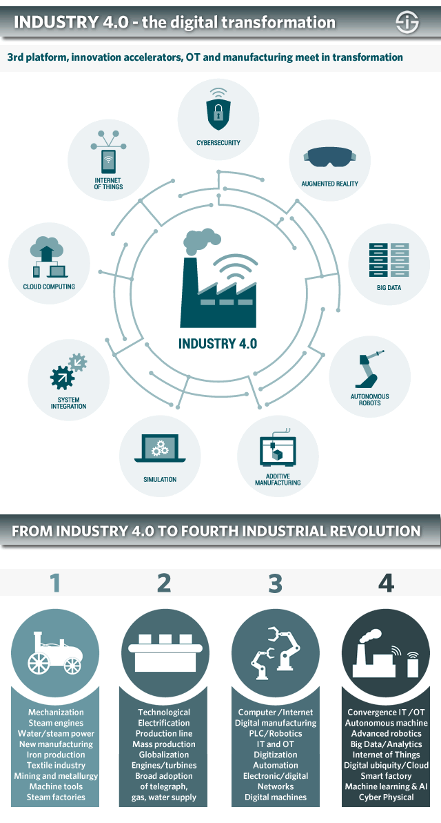

- Using the first provided image, desribe in your own words what ist he Industry 4.0. Which of the shown elements do you think contribute the most to Industry 4.0?
Industry 4.0 is ……..

- Given the written passage from online platform, give two examples of real life situations when you came across the Industry 4.0 yourself.
2.

- The Second Image shows the History of Industry 4.0. Describe the Importance on Society of each of them. Factors that could be considered: education, economics, environment, etc.

