DigI – VET
FOSTERING DIGITISATION AND INDUSTRY 4.0 IN VOCATIONAL EDUCATION AND TRAINING

Intellectual Output 4 – Teaching & Learning Material

Table of Contents
Module C 14
General Aspects of Digitisation at Industry 14

Module C

General Aspects of Digitisation at Industry

While considering the aspects of how digitisation affects the Industry, the concept of Internet of Things is essential. It is connection between Internet and Device and the effect of this relationship towards other connected devices. E.g. self-driving cars, fitness devices measuring different aspects (e.g. heart rate, steps).
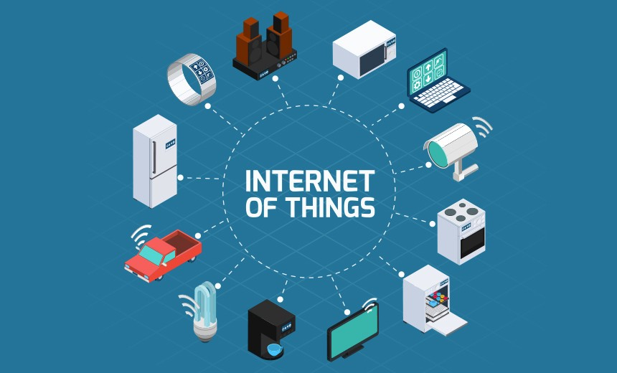
(https://towardsdatascience.com/iot-in-action-a8b7fac83619)

Task
Describe the Internet of Things, describe how it affects Industry and out of 12 chosen examples in the provided image, choose 5 and elaborate on their impact for Industry.

