DigI-VET
Fostering Digitization and Industry 4.0 in vocational education
2018-1-DE02-KA202-005145

The DigI-VET sMOOC Concept

UPB – Jennifer Schneider

Project Title DigI-VET

Reference Number 2018-1-DE02-KA202-005145

Content
1. The DigI-VET sMOOC Concept 3
1.1 Main target group and sMOOC structure of the DigI-VET sMOOC 4
1.2 Aims and Outcomes of the DigI-VET sMOOCs 6
1.3 Opportunities to implement the DigI-VET sMOOC in VET 7
2. General information about the platform MOOCit 8

The DigI-VET sMOOC Concept

The Erasmus+ Project DigI-VET "Fostering Digitization and Industry 4.0 in Vocational Education and Training." created a sMOOC which runs on the MOOC platform MOOC-IT.
On the one hand it offers the information on the results and the current situation in digitisation/ digitalisation, Industry 4.0 and challenges & opportunities for VET and businesses to a broad audience and
on the other hand it can be used in VET-courses and VET schools.
The idea of the DigI-VET sMOOC concept is to offer a combination of graphics, texts, interactive tasks, links to further literature, the project website and social media. This provides an great overview for teachers and learners and makes the content of the sMOOC transferable to different parts of the VET system as well as interesting for enterprises.
The sMOOC are available in all partner languages (DE, EN, GR and RO) and are part of the Intellectual Outcomes IO2 of the DigI-VET project:
Here the links to the sMOOCs in the national partner languages:

The DigI-VET sMOOC
English sMOOC:
https://moocit.de/index.php?title=DigI-VET_-_English_sMOOC
Geman sMOOC:
https://moocit.de/index.php?title=DigI-VET_-_German_sMOOC
Greek/Cypriot sMOOC:
https://moocit.de/index.php?title=DigI-VET_-_Cypriot-Greek_sMOOC
Romanian sMOOC:
https://moocit.de/index.php?title=DigI-VET_-_Romanian_sMOOC

To sum up the core aspects of the DigI-VET sMOOC concept, this paper explains the following topics:

- Main target group and sMOOC structure of the DigI-VET sMOOC
- Aims and Outcomes of the DigI-VET sMOOCs
- Opportunities to implement the DigI-VET sMOOC in VET

1.1 Main target group and sMOOC structure of the DigI-VET sMOOC

In general the DigI-VET sMOOC is created for a wide audience of the field of vocational education. Teachers as well as vocational trainers and human resource developers in businesses can use the sMOOC to get information about digitalisation/ digitisation and Industry 4.0. Because of the different topics of the sMOOC the interested reader get - on the one hand - information about best practices and businesses, which implement features of digitalisation in their daily business and - on the other - hand teachers and educators get further information about competences which has to be teached, information about the curriculum and for example an overview and links to teaching and learning materials which can be used as Open Educational Resource in their classroom activities or for blended learning.
Moreover, learner and students of VET are person of the main target group, too. The different learning materials which are linked in the sMOOC are great to use for self-learning sessions. A variety of H5P tasks complete the input parts, while allowing further self-learning parts.
In total, the sMOOC makes it easier to find information on digitization and industry 4.0 and thus to obtain a basis for using it adequately. It helps to create innovative vocational training and to adopt a European approach.
That's why we decided to provide the following information and learning activities about:

Table of content of the DigI-VET sMOOC:
1 Information on the DigI-VET sMOOC
1.1 Main target groups
1.2 Aims of the DigI-VET sMOOCs
1.3 Outcome
1.4 Structure of the DigI-VET-sMOOC
2 Introduction
3 The DigI-VET Project
4 Insights about challenges and opportunities of digitization and Industry
4.1 Economic Opportunities
4.2 National and international learning landscape
5 The DigI-VET Curriculum and Profiles
5.1 DigI-VET Learning Outcome Matrix and the DigI-VET Curriculum – Integration into course structures
5.2 Aspects and challenges for the target group of teachers, trainers as well as learners, pupils and students in the field of vocational training
6 Overview of the digitization competence profile
7 Digitization and skills in vocational teaching and VET classroom
7.1 Digital Competence Profile of DigI- VET
7.2 DigI-VET learning and teaching materials
7.2.1 Training modules for teachers and trainers in VET
7.2.2 Training modules for learner
8 DigI-VET Learning platform

To summarize the idea of the DigI-VET sMOOC the eight chapters were created to inform the wide audience about the
idea of DigI-VET
insight into the difference between digitization and digitalization
insights into possible competence profiles
the presentation of the importance of pre- and post-processing sequences
And further more

Therefore, please visit the DigI-VET sMOOC and the DigI-VET website to get all necessary information:
http://digivet.eduproject.eu/?lang=de

1.2 Aims and Outcomes of the DigI-VET sMOOCs

The DigI-VET sMOOC force to give vocational teachers and trainers insights into the challenges and opportunities of digitisation in VET and provide an overview of the DigI-VET competence profile for digitisation. Additionally, it offers examples and best practices of implementing of digitisation and Industry 4.0 in daily business and gives teachers and trainers hints to implement new ideas of digitisation and didactical approaches for their classes and general teaching activities. This raise awareness of challenges in VET, too. This is also on of the reasons why the DigI-VET project focused on a suitable curriculum approach and teacher and learner modules for classes and online sessions.
Therefore, the target group of the DigI-VET sMOOC gain knowledge about the challenges and opportunities of digitization in VET contexts and in the field of digitization, while focusing European education approaches to digitisation. The consortium of the project focus on European educational approaches to digitization, too. And give space to rethink the form of digitisation training and Industry 4.0 – in VET. To complete the focused outcomes and aims of the sMOOC and general aims of the project, the target group get information about the core results of the Erasmus+ project DigI-VET: this includes information about the DigI-VET website, social media accounts and outcomes in general, with the hint to download the from the website.
At least, the impact of the DigI-VET sMOOC is usually huge in this field and it reachs more than 250 users already during the project. Due to the fact, that thw sMOOC is completle autarc and online available at the host platform MOOC-IT, it also guarantees sustainability after the end of DigI-VET!

1.3 Opportunities to implement the DigI-VET sMOOC in VET

Digitisation, digitalisation and aspects of Industry 4.0 become part of our daily life, even in the environment of our classroom and influences our teaching and learning behaviour. That means that the rise of digitisation in schools relives in many parts the “traditional” teaching methods and take new technologies, solutions and tools over classrooms.
The DigI-VET sMOOC permit the opportunity to use a digital online MOOC tool, which have the potential to increase the learning productivity and fascination of the learner.
The Pädagogische Hochschule Freiburg is a German University of Education and offers the platform MOOCit, as a German result to use, create and share Massive Open Online Courses. The tool offers the opportunity to educational learning content, while being user-friendly and offering quick and uncomplicated access without an additional login. This helps teachers and trainers to integration the DigI-VET sMOOC so easy in their daily classes.
On the one hand the sMOOC can be used as a tool for blended learning scenarios:
During the in- classroom teaching the teacher and trainer can use the DigI-VET teaching and learning modules from Intellectual outcome 4 to teach aspects of digitisation, Internet of Things, the history of Industry 4.0 or other important topics. Because of the fact, that all modules are created under Creative Commons licence the audience can remix, change, spilt and reuse the content and adapted them for their in- classroom teaching needs.
For the at-home classes, what means online self-learning sessions, the learner can be free to use the sMOOC and learn more in detail different aspects of the Erasmus+ project DigI-VET. Therefore, the sMOOC provides for example content about best practices and the link to the Online Observatory or explains aspects of the competence profile of DigI-VET.
To sum up, the DigI-VET sMOOC is an additional building block and complete the learner centred learning and teaching approach of the project. Therefore, the online tool offers convenience and flexibility in time. The audience get the ability to control their learning pace, learn remotely, while being also flexible in working place. Research results explains, that this concept gives learners more comprehensive understanding of the course content, than it has in only in-classroom teaching. At least, social learning will be supported by this concept. Learners can organise digital online groups to discuss the topics and contents, to solve the implemented H5P tasks or to use additional chat options on social media accounts.

General information about the platform MOOCit

The platform MOOCit is a free offer of Massive Open Online Courses- short MOOCs, for everyone involved in school/ educational life and includes Mini Open Online Courses, short Mini MOOCs as well as regular Massive Open Online Courses, short MOOCs. The German Pädagogische Hochschule Freiburg is a University of Education that creates this online platform for learner and trainer to share, create and remix online learn courses. The slogan of the platform says:
Online Courses from learner to learner!
So, everyone can be creator, trainer and teacher of a topic and learner of another subject at the same time. As already explained, the online courses structure can be used for blended- learning classes and self- learning sessions, too.
Therefore, the creators of MOOCit define the following features of the online tool:
- MOOC = Massive Open Online Course (video-supported internet learning course with interactive tasks)
- it = invitation to act or IT (information technology)
- P4P = No university elite course, but by and for students (peer for peer)
- Mini = Small, manageable, feasible topic section (no complex MOOC)
MOOCit offers advanced trainings in MOOCs in education with the most powerful and flexible design. It animates and distribute learner and trainer online courses in a great digital transformation of training activities. At least with the integration of H5P tasks (see In Detail: Focus on H5P.org).
MOOCit has a greate explanation and guidelines how to create a MOOC on MOOCit, because of the fact that MOOCit is a German example of MOOC creator the website is in German language as well as guidelines. Moreover, there is a video that describes step by step the creation of a new MOOC, too. Therefore, no programming skills are needed, the user-friendly step-by-step explanation of MOOCit describes how to create a new module.
The following screenshots give an example how the sMOOC of DigI-VET looks like:

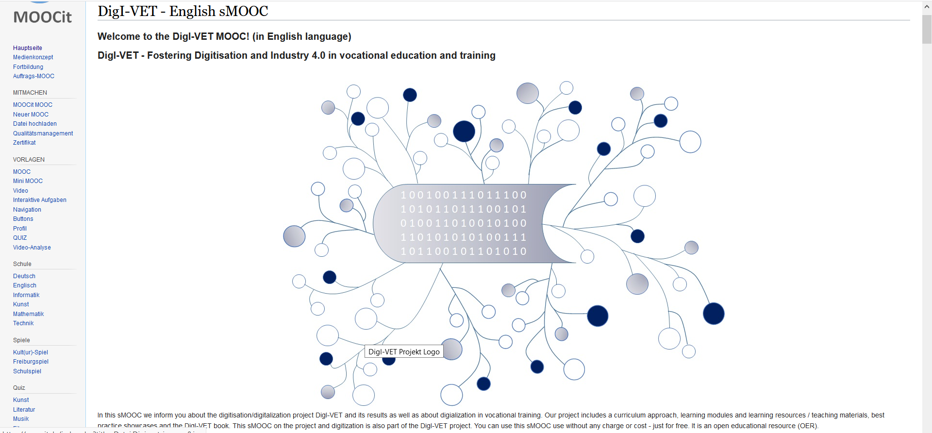
Figure 1 Screenshot of the DigI-VET sMOOC I

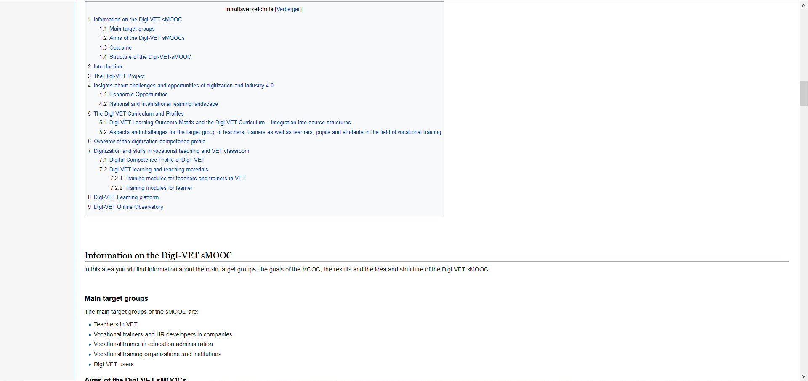
Figure 2 Screenshot of the DigI-VET sMOOC II
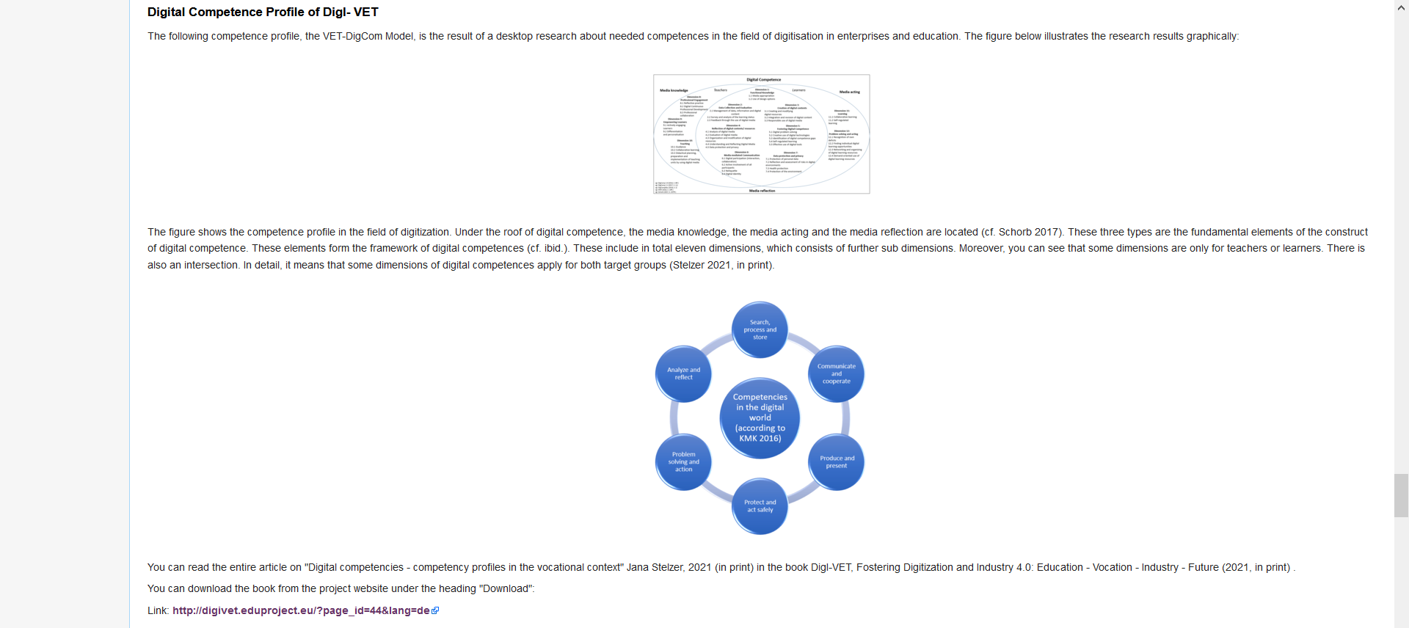
Figure 3 Screenshot of the DigI-VET sMOOC II

You can find further information on the MOOCit website – Link: https://moocit.de/
Published in: https://moocit.de/index.php?title=DigI-VET_-_English_sMOOC, Access date: 26.03.2021.
Ebd.
Published in: https://moocit.de/index.php?title=DigI-VET_-_English_sMOOC, Acess date: 26.03.2021.

