DigI-VET
Fostering Digitization and Industry 4.0 in vocational education
2018-1-DE02-KA202-005145

The fifteen Core Results of the project DigI-VET
The DigI-VET digitisation concept for VET

UPB – Jennifer Schneider

Project Title DigI-VET

Reference Number 2018-1-DE02-KA202-005145

The DigI-VET digitisation concept for VET

The DigI-VET digitisation concept for VET comes with an action and implementation concept and a step- by- step-approach for implementation. Moreover, DigI-VET tested if the results of the project fit to the needs of specific job profiles e.g. in Germany with regard to the apprenticeship Industriekaufmann/ -frau (industrial clek) and the apprenticeships have a specific process- oriented and situated curricular approach (Lernfeldkonzept- concept of learning fields). Also in the other countries there is the check for the fit of the DigI-VET results with regard to jobs in the field of industry and office with the specific focus and then fit to the clerk jobs.
The digitisation concept offers the check if national regulations fit to the results of DigI-VET. In all partner countries such fits could be found and the matching helps the partners and people in the partner countries to implement the results within the specific national educational system.

Digitisation concept for VET – Focus on clerk jobs in Germany

The following table “Focus on Industrial Clerk” gives a short presentation of the industrial clerk apprenticeship, its supporting competences and skills as well as first impressions of its process- oriented and situated curricular approach, which will be summarised in the “Concept of learning fields”. Due to the fact the curriculum of Industrial Clerk is in German language, the table gives an additional translation of the text.

In detail: Focus on Industrial Clerk
Kurze Vorstellung des Ausbildungsberufs Industriekaufmann* frau | Brief presentation of the industrial clerk apprenticeship
„Der Industriekaufmann/die Industriekauffrau ist in Unternehmen unterschiedlicher Branchen und Größen tätig, die zunehmend nicht nur Produkte herstellen, sondern auch ergänzende und eigenständige Dienst- und Serviceleistungen zum Teil in umfangreichen Projekten anbieten. Industriekaufleute verfügen über ein nicht nur auf die industrielle Fertigung bezogenes breites kaufmännisches Grundwissen, insbesondere auch im Bereich der Kundenberatung, Kundenbetreuung und der Projektabwicklung. Das Berufsbild umfasst arbeitsfeldübergreifende Qualifikationen, Fachqualifikationen und profilgebende Einsatzbereiche, in denen branchen- bzw. betriebsbezogene Qualifikationen im Hinblick auf einen angestrebten Arbeitsplatz erworben werden. Kundenorientierung und geschäftsprozessbezogene Handlungskompetenz werden besonders herausgestellt.  Betriebliche und schulische Ausbildung ermöglichen den Zugang zu grundlegenden betriebswirtschaftlichen Problemstellungen und Begriffen aus einer geschäftsprozessorientierten Sicht. Die Förderung von Orientierungswissen, das Lösen komplexer und exemplarischer Aufgabenstellungen, systemorientiertes und vernetztes Denken und Handeln sind Bestandteil der Ausbildung.“ (Rahmenlehrplan für den Ausbildungsberuf Industriekaufmann/Industriekauffrau (Beschluss der Kultusministerkonferenz vom 14.06.2002, S. 7). | The industrial clerk works in companies of different industries and sizes, which increasingly not only manufacture products, but also offer supplementary and independent services, some in extensive projects. Industrial clerks have a broad basic commercial knowledge that is not only related to industrial production, especially in the area of ​​customer advice, customer care and project management. The job description includes cross-field qualifications, specialist qualifications and profile-giving areas of activity in which industry or company-related qualifications are acquired with a view to a desired job. Customer orientation and business process-related skills are particularly emphasized.  In-company and school-based training enable access to basic business management problems and terms from a business process-oriented point of view. The promotion of orientation knowledge, the solving of complex and exemplary tasks, system-oriented and networked thinking as well as acting are part of the training (Translation: Rahmenlehrplan für den Ausbildungsberuf Industriekaufmann/Industriekauffrau (Beschluss der Kultusministerkonferenz vom 14.06.2002, S. 7).
Lernfelder des Rahmenlehrplans – Lernfeldkonzept | Process- oriented and situated curricular approach – Concept of learning fields
Die Lernfelder dieses Rahmenlehrplanes orientieren sich an typischen Geschäftsprozessen eines Industrieunternehmens. Die Auftragsabwicklung wird als wesentlicher Kernprozess  betrachtet, aus dem heraus sich unterstützende Prozesse mit Schnittstellen zu weiteren Kernprozessen ergeben. Die Abgrenzung der Lernfelder berücksichtigt die Unterscheidung von Kern- und unterstützenden Prozessen. Ihre Zielformulierungen ermöglichen didaktisch unterschiedliche Reihenfolgen der Lernfelder in einem Ausbildungsjahr. Insbesondere im Hinblick auf das erste Ausbildungsjahr ist hierzu eine Abstimmung vor Ort erforderlich. Neben anderen Lernfeldern greift vor allem Lernfeld 12 die zunehmende Projektarbeit in den Betrieben auf und leistet über die Entwicklung einer umfangreichen Eigenverantwortlichkeit im Hinblick auf die Einschätzung und Optimierung von Abläufen einen wesentlichen Beitrag zur beruflichen Qualifizierung.“ (Rahmenlehrplan für den Ausbildungsberuf Industriekaufmann/Industriekauffrau (Beschluss der Kultusministerkonferenz vom 14.06.2002, S. 7). | The learning areas of this framework curriculum are based on typical business processes of an industrial company. Order processing is an essential core process from which supporting processes with interfaces to other core processes result. The delimitation of the learning fields takes into account the distinction between core and supporting processes. The formulations of their goals enable the didactically different sequences of the learning fields in an apprenticeship year. On-site coordination is required, particularly with regard to the first year of training. In addition to other learning fields, especially learning field 12 takes up the increasing project work in the companies and makes a significant contribution to professional qualification through the development of extensive personal responsibility with regard to the assessment and optimization of processes (Translation: Rahmenlehrplan für den Ausbildungsberuf Industriekaufmann/Industriekauffrau (Beschluss der Kultusministerkonferenz vom 14.06.2002, S. 7).
Geförderte, umfassend (Handlungs-) Kompetenzen | Decision- making and responsibility – Competences
Zur Betonung sind Personal-, Sozial-, Methoden- und Lernkompetenz in einigen Lernfeldern ausdrücklich verankert. Sie sind in den anderen Lernfeldern weiter aufzugreifen und zu festigen. Eine frühere Thematisierung oder eine spätere vertiefende Anwendung bleibt davon unberührt.  Die Informationsbeschaffung, -verarbeitung und –auswertung erfolgt integrativ über Medien und informationstechnische Systeme in allen Lernfeldern. Hierfür ist ein Gesamtumfang von mindestens 80 Stunden im Rahmenlehrplan berücksichtigt. Die Vermittlung von fremdsprachlichen Qualifikationen gemäß der Ausbildungsordnung zur Entwicklung entsprechender Kommunikationsfähigkeit ist mit 40 Stunden in die Lernfelder integriert. Darüber hinaus können 80 Stunden berufsspezifische Fremdsprachenvermittlung als freiwillige Ergänzung der Länder angeboten werden. Die Lernfelder des zweiten und dritten Ausbildungsjahres bieten Anknüpfungen für fremdsprachliche Lernsituationen“ (Rahmenlehrplan für den Ausbildungsberuf Industriekaufmann/Industriekauffrau (Beschluss der Kultusministerkonferenz vom 14.06.2002, S. 7). | To emphasize, personal, social, methodological and learning skills are expressly anchored in some learning fields. They are to be taken up and consolidated in the other learning fields. An earlier theming or a later in-depth application remains unaffected.  Information acquisition, processing and evaluation takes place interactively via media and information technology systems in all learning fields. For this purpose, a total of at least 80 hours is taken into account in the framework curriculum. The teaching of foreign language qualifications in accordance with the training regulations for developing appropriate communication skills is integrated into the learning fields with 40 hours. In addition, 80 hours of job-specific foreign language teaching can be offered as a voluntary addition to the federal states. The learning fields of the second and third year of training offer opportunities to foreign language learning situations (Translation: Rahmenlehrplan für den Ausbildungsberuf Industriekaufmann/Industriekauffrau (Beschluss der Kultusministerkonferenz vom 14.06.2002, S. 7).
Table 1 Focus on Industrial Clerk – Overview (German and English translation). Diagram by author.

The DigI-VET Action and implementation concept – a step- by- step-approach for implementation

The latest chapter give an overview of the German VET apprenticeship as Industrial Clerk. In addition, the core curriculum comes together with an additional overview of the concept of learning fields (Lernfeldkonzept). This concept explains, more or less in detail, what and how the learners shall learn during the three years of apprenticeship. Therefore, 12 learning fields have been established and time frames / hours for learning and teaching, have been defined (see table 2: Industrial Clerk: Concept of learning fields (Rahmenlehrplan für den Ausbildungsberuf Industriekaufmann/Industriekauffrau (Beschluss der Kultusministerkonferenz vom 14.06.2002, S. 8).

Nr./ No. | Lernfelder | 12 learning fields
1 | In Ausbildung und Beruf orientieren | Orientation in training and career
2 | Marktorientierte Geschäftsprozesse eines Industriebetriebes erfassen | Record market-oriented business processes of an industrial company
3 | Werteströme und Werte erfassen und dokumentieren | Record and document value streams and values
4 | Wertschöpfungsprozesse analysieren und beurteilen | Analyze and assess value creation processes
5 | Leistungserstellungsprozesse planen, steuern und kontrollieren | Plan, manage and control service creation processes
6 | Beschaffungsprozesse planen, steuern und kontrollieren | Plan, manage and control procurement processes
7 | Personalwirtschaftliche Aufgaben wahrnehmen | Perform human resource management tasks
8 | Jahresabschluss analysieren und bewerten | Analyze and evaluate the annual financial statements
9 | Das Unternehmen im gesamt- und weltwirtschaftlichen Zusammenhang einordnen | Classify the company in the macroeconomic and global economic context
10 | Absatzprozesse planen, steuern und kontrollieren | Plan, manage and control sales processes
11 | Investitions- und Finanzierungsprozesse planen | Plan investment and financing processes
12 | Unternehmensstrategien, -projekte umsetzen | Implement corporate strategies and projects
Table 2 Concept of learning fields (Lernfelder) – English translation.
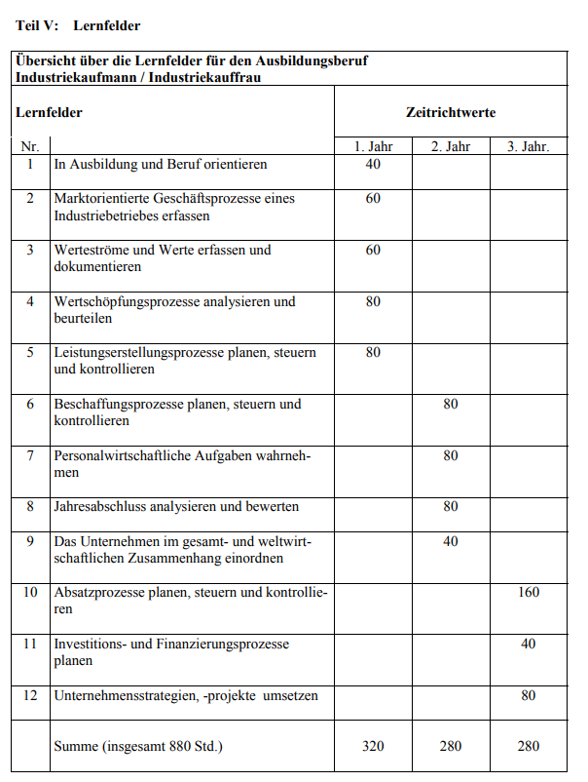
Table 3 Industrial Clerk: Concept of learning fields (Rahmenlehrplan für den Ausbildungsberuf Industriekaufmann/Industriekauffrau (Beschluss der Kultusministerkonferenz vom 14.06.2002, S. 8).

The DigI-VET Step-by-step approach for implementation

The DigI-VET digitisation concept for VET focus on this learning fields and recommend a step- by- step approach to integrate the topic “digitisation, digitalisation and digital transformation as well as Industry 4.0” in the learning fields of (in this case industrial) clerk apprenticeship. Therefore, the DigI-VET approach focus on the learning fields 1, 5, 7, 8 and 12, because of the importance of using digital/ online media and medium. Moreover, the approach gives a short hint to the addressed

Nr./ No. | 12 learning fields | Short description | DigI-VET – digitalisation step-by- step approach for implementation | Competences and skills
1 | Orientation in training and career | “[…] The students work on tasks independently in groups  and apply problem-solving methods. They deal reflexively with conflicts that arise and regulate them constructively. They present and document theirs structured work results using appropriate media. They use modern communication media to obtain information.” | Integration of Training modules of DigI-VET:  Training Modules for learners  - Module A: Digitisation Terms and history  - Module B: Industry 4.0 Terms and history  - Module C: Current status and future development  Optional:  Selflearning phase about the importance of digitisation  Embedding the DigI-VET sMOOC  English sMOOC:  https://moocit.de/index.php?title=DigI-VET_-_English_sMOOC  Geman sMOOC:  https://moocit.de/index.php?title=DigI-VET_-_German_sMOOC  Greek/Cypriot sMOOC:  https://moocit.de/index.php?title=DigI-VET_-_Cypriot-Greek_sMOOC  Romanian sMOOC:  https://moocit.de/index.php?title=DigI-VET_-_Romanian_sMOOC | - Methodological and learning skills  - (vocational) action competence: occupational competence, personal competences and social competences
5 | Plan, manage and control service creation processes | “As part of quality management, the students explain procedures  for process optimization, which in the phases of product or service creation the  Ensure and further develop the quality of the product or service. When carrying out the various tasks, they use suitable information technology systems to monitor and maintain the required data.  The students solve problem-oriented tasks in teams. you  document and present their results. They reflect on learning progress and develop learning strategies.” | Embedding the DigI-VET sMOOC:  English sMOOC:  https://moocit.de/index.php?title=DigI-VET_-_English_sMOOC  Geman sMOOC:  https://moocit.de/index.php?title=DigI-VET_-_German_sMOOC  Greek/Cypriot sMOOC:  https://moocit.de/index.php?title=DigI-VET_-_Cypriot-Greek_sMOOC  Romanian sMOOC:  https://moocit.de/index.php?title=DigI-VET_-_Romanian_sMOOC  Optional:  Idea of using a blended learning approach – see DigI-VET blended learning approach (chapter 14ff.). | - Methodological and learning skills  - (vocational) action competence: occupational competence, personal competences and social competences
7 | Perform human resource management tasks | Taking into account personnel regulations from labor and social law, collective bargaining law and company agreements, they evaluate employment contracts and the consequences for them  Relocations and layoffs. They develop concepts for basic, advanced and advanced training to actively shape personnel development and improve employee motivation. In doing so, they also recognize the importance of lifelong learning for personal development and the active shaping of their own professional future.  They assess job evaluation criteria and the remuneration systems, and calculate remuneration  and book them. | Embedding the DigI-VET Online Observatory and training modules/ classroom materials to get in touch with existing best practices and successful companies which integrate the idea of Industry 4.0 and digitisation in their daily life and work.  Optional:  Integration of Training modules of DigI-VET:  Training Modules for learners  - Module A: Digitisation Terms and history  - Module B: Industry 4.0 Terms and history  - Module C: Current status and future development | - Methodological and learning skills  - (vocational) action competence: occupational competence, personal competences and social competences
8 | Analyze and evaluate the annual financial statements | “The pupils select suitable media for processing their tasks, present their work results and justify their conclusions.” | Embedding the DigI-VET learning platform to foster individual self- learning phases with the opportunity to transfer the contents in the classroom  Optional:  Idea of using a blended learning approach – see DigI-VET blended learning approach (chapter 14ff.). | - Methodological and learning skills  - (vocational) action competence: occupational competence, personal competences and social competences
12 | Implement corporate strategies and projects | “In the course of the project, they take responsibility for compliance with the established rules, document the progress of the project, analyze and evaluate the course of the project and present  the result. They communicate in teams and use information and documentation  and presentation also justifies selected technical systems and media.” | Embedding the DigI-VET Online Observatory and training modules/ classroom materials to get in touch with existing best practices and successful companies which integrate the idea of Industry 4.0 and digitization in their daily life and work.  Optional:  Idea of using a blended learning approach – see DigI-VET blended learning approach (chapter 14ff.). | - Methodological and learning skills  - (vocational) action competence: occupational competence, personal competences and social competences

For more information regarding DigI-VET competences profile and skills please have a closer look in the DigI-VET book. Moreover, visit the DigI-VET project website to download the classroom materials and additional supporting materials and guidelines.

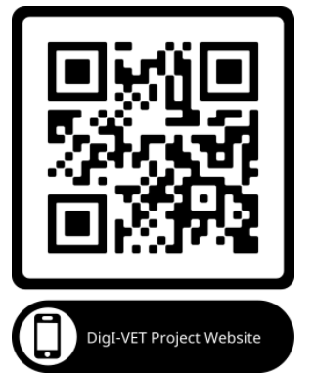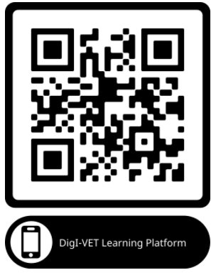

DigI-VET website: http://digivet.eduproject.eu/?lang=de
DigI-VET Online Observatory: http://digivet-platform.eduproject.eu/
Learning Plattform: http://digivet-tasks.eduproject.eu/de/digi-vet-willkommen/

References

DigI-VET (2021): Project website. Retrieved from the Internet: http://digivet.eduproject.eu/?lang=de. Access date: 28.05.2021.

R A H M E N L E H R P L A N für den Ausbildungsberuf Industriekaufmann/ Industriekauffrau (Beschluss der Kultusministerkonferenz vom 14.06.2002). Retrieved from the Internet: https://www.kmk.org/themen/berufliche-schulen/duale-berufsausbildung/downloadbereich-rahmenlehrplaene.html?tx_fedownloads_pi3%5Bcontroller%5D=Downloads. Access date: 28.05.2021.

