DigI-VET
Fostering Digitization and Industry 4.0 in vocational education
2018-1-DE02-KA202-005145

The fifteen Core Results of the project DigI-VET

UPB – Jennifer Schneider

Project Title DigI-VET

Reference Number 2018-1-DE02-KA202-005145

Content
(1) The DigI-VET publications, newsletter and press articles 3
(2) Dissemination Plan 3
Dissemination Activities of the DigI-VET Project: 5
Templates: 5
Dissemination Tables of the consortium: 5
Dissemination Plan: 5
Social Media Roster: 5
DigI-VET Project Dissemination Activities – Overview: 5
DigI-VET Videos: 7

The DigI-VET publications, newsletter and press articles

The DigI-VET publications, newsletter, press articles as well as dissemination materials like poster, leaflets or brochures (see chapter 7) are parts of a five stage model for dissemination which is basis of the DigI-VET project. The following Dissemination Plan, which is downloadable at the DigI-VET website, too explains the five stages and shows a list of all dissemination activities the partner consortium made in the project lifetime and even beyond the lifetime.

(2) Dissemination Plan

The Dissemination Plan for the DigI-VET project is designed on the basis of the five-stage model for dissemination and exploitation of the European Union.

The five strategic levels are described as follows:

1. A clear rationale for and objectives of dissemination and exploitation;
2. A strategy to identify which results to disseminate and to which audiences – and designing programmes and initiatives accordingly;
3. Determining organisational approaches of the different stakeholders and allocating responsibilities and resources;
4. Implementing the strategy by identifying and gathering results and undertaking dissemination and exploitation activities;
5. Monitoring and evaluating the effects of the activity.

This document will be used by partners as a guide to their efforts to enhance the dissemination and exploitation action results within the framework of the DigI-VET project. Firstly, the Dissemination Plan defines the rationale of the DigI-VET project and provides an overview, identifies the Dissemination Objectives and the Target Groups which will be addressed during the dissemination process. Secondly, the Dissemination Plan identifies the Partner Dissemination Responsibilities, Dissemination Strategies and Means of Dissemination, which will be employed in order to reach the objectives of the DigI-VET project and address the target audiences effectively.

Here the table of content of the DigI-VET Dissemination Plan:
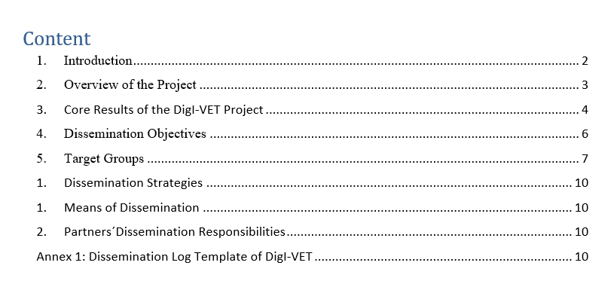

Please click on the following link to download the DigI-VET Dissemination Plan:
http://digivet.eduproject.eu/wp-content/uploads/2021/07/DigI-VET-Dissemination-Plan-UPB.pdf
As well as all other information under “Dissemination Activities of the DigI-VET Project”:
http://digivet.eduproject.eu/?page_id=368&lang=de

Summary of all documents developed at the Erasmus+ project DigI-VET

2.1 Dissemination Activities of the DigI-VET Project

Dissemination Tables of the consortium:
DigI-VET- Dissemination Log Template – final
Dissemination Plan:
DigI-VET- Dissemination Plan – UPB

2.1.1 Templates

Dissemination Log Template
DigI-VET-Dissemination Log Template blanko
Social Media Roster:
DigI-VET_Social Media_Roster

2.1.2 DigI-VET Project Dissemination Activities – Overview:
PR Article:
DigI-VET-Dissemination Activity-7-Printed activities
DigI-VET-Dissemination Activity-3.1-3.3-PRTerminal- article
DigI-VET-Dissemination Activity-3.4-PRTerminal- article
DigI-VET-Dissemination Activity-3-PRTerminal- article
Newsletter:
DigI-VET- Dissemination Activity- Newsletter 1-EN
DigI-VET- Dissemination Activity- Newsletter 1-GR
DigI-VET- Dissemination Activity- Newsletter 1-RO
DigI-VET- Dissemination Activity- Newsletter 2-DE
DigI-VET- Dissemination Activity- Newsletter 2-EN
DigI-VET- Dissemination Activity- Newsletter 2-GR
DigI-VET- Dissemination Activity- Newsletter 2-RO
DigI-VET- Dissemination Activity- Newsletter 1-DE

Face- to Face:
DigI-VET-Dissemination Activity-6.1-Face-to-Face
DigI-VET-Dissemination Activity-6.2-Face-to-Face
DigI-VET-Dissemination Activity- Online presentation
Website:
DigI-VET-Dissemination Activity-2.2-Website_UPB
DigI-VET-Dissemination Activity-2.1-Website_UPB
DigI-VET-Dissemination Activity-1.3-Website
DigI-VET-Dissemination Activity-1.2-Website
DigI-VET-Dissemination Activity-1.1-Website
DigI-VET-Dissemination Activity-1.4-Website
DigI-VET-Dissemination Activity-1.5-Website
Poster:
DigI-VET-Dissemination Activity-4-poster
DigI-VET Poster Feb
DigI-VET Poster-II-DE
DigI-VET Poster-II-EN
DigI-VET Poster-III-DE
DigI-VET Poster-III-EN
DigI-VET Poster DE
DigI-VET Poster DE
DigI-VET Poster EN
DigI-VET Poster EN
Flyer:
DigI-VET-Flyer UPB – ENG
DigI-VET-Flyer UPB – ENG-Platform
DigI-VET-Flyer UPB – German
DigI-VET-Flyer UPB – German-Platform
DigI-VET-Flyer UPB – German-sMOOC-II
DigI-VET-Flyer UPB – EN- sMOOC-II
Banner:
DigI-VET-Banner – EN
Brochure:

2.2 Social Media Activities

Facebook:
facebook.com/digiveteu

DigI-VET Videos:
Emphasis / Greek:
Link:
- https://www.youtube.com/watch?v=3901LOHtn5Q
- https://www.youtube.com/watch?v=s_5aFKCaMTQ
- https://www.youtube.com/watch?v=HxTC4g2JeXA&t=5s
Asociatia Oamenilor de Afaceri Agres (AOAA) / Romania:
Link:
- https://www.facebook.com/watch/?v=299170115075685
- https://www.facebook.com/digiveteu/videos/299170115075685
- https://www.facebook.com/digiveteu/videos/478511896682655University of Paderborn / German:
Link:
- https://www.youtube.com/watch?v=pV9odCQfuPo&t=12s
- https://www.youtube.com/watch?v=9xD7xDHE88kAR Vocational Education and Training Ltd. (ARVET) / United Kingdom:
Link:
- https://www.facebook.com/350233285814676/videos/316506723331935
- https://www.facebook.com/350233285814676/videos/482244546356169
- https://www.facebook.com/350233285814676/videos/283125873483055

