DigI-VET
Fostering Digitization and Industry 4.0 in vocational education
2018-1-DE02-KA202-005145

The fifteen Core Results of the project DigI-VET
The DigI-VET Website with Blog

UPB – Jennifer Schneider

Project Title DigI-VET

Reference Number 2018-1-DE02-KA202-005145

The DigI-VET Website with Blog

The DigI-VET website is one of the main project results of the DigI-VET consortium. It helps to spread the research results of the project, the teaching and learning materials and modules for VET teachers/ trainers and learners as well as give a wide audience the opportunity to download all project documents in an easy and comfortable way. At least all information about the sMOOC and Online Observatory as well as actual information and hints to social media activities are linked on the website and helps the audience to find their search orders. The Blog on the website allows a direct communication with interest readers and shows a user-friendly way to get in touch with the audience.
Here the link to the DigI-VET website:
http://digivet.eduproject.eu/

All information of the project are classified under the tabs:
- Project
- Download
- Online Observatory
- Social Network
- Gallery
- Conveyor
- Language

Here a screenshot of the DigI-VET website:
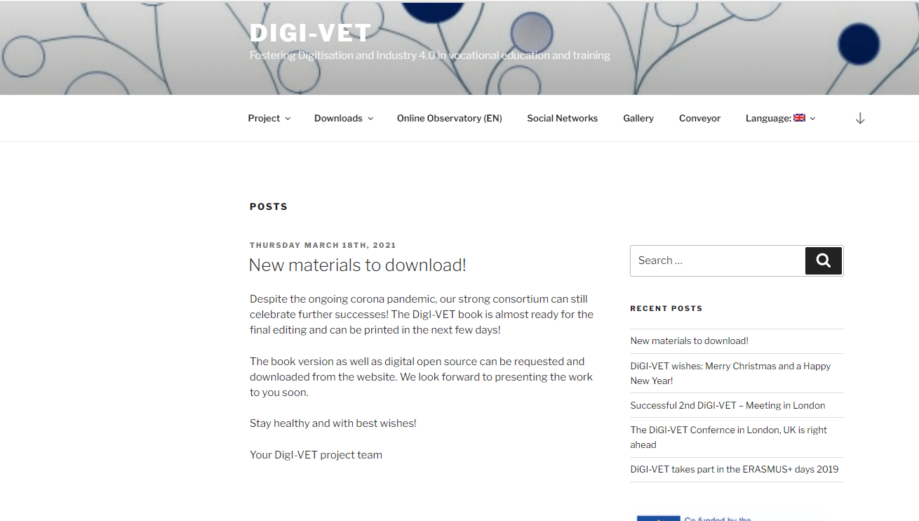
Figure 1 Screenshot of the DigI-VET project website

Link: http://digivet.eduproject.eu/

