Dissemination Activity-6.1
DigI-VET:
Fostering Digitisation and Industry 4.0 in vocational education and training
Project No: 2018-1-DE02-KA202-005145

Nr. | Art | Datum | Link
1 | Face-to-Face | 23.10.2019 | See Screenshot

Screenshots (25.10.2019):
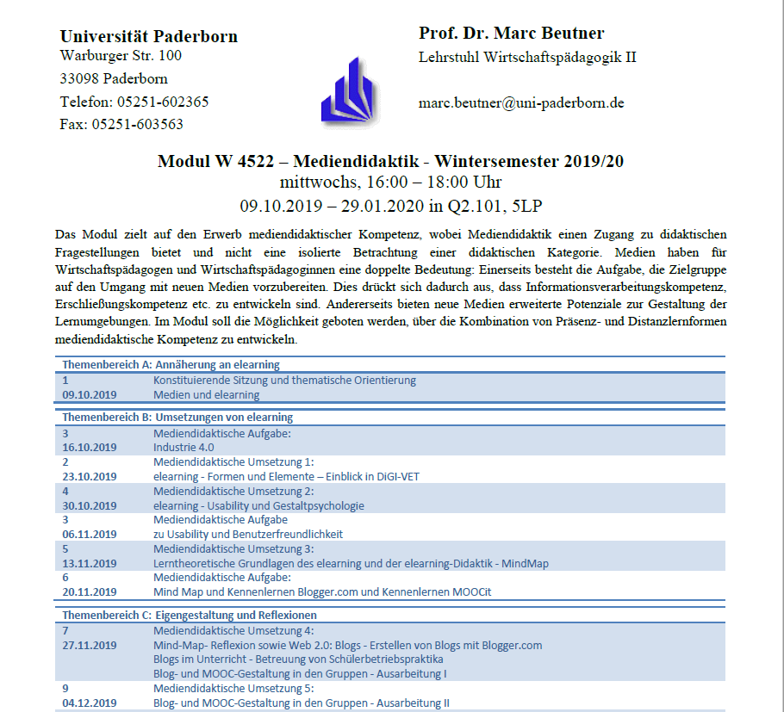

Presentation of DiGI-VET project at university seminar “Mediendidaktik.

