

**The DiGI-VET project**

In the last few years digitisation is becoming more and more important. This goes hand in hand with trends towards mobile learning. The Erasmus+ project DigI-VET "Fostering Digitisation and Industry 4.0 in vocational education and training" addresses new and innovative ways of learning and teaching in the age of digitisation and Industry 4.0.

The five project partner are coming from four European countries: Germany (2 partners), United Kingdom, Cyprus and Romania.

The German partners are responsible for coordination. Ingenious Knowledge GmbH focusses on structure, concept, technical and book design and the programming.

The University Paderborn, Chair of Business and Human Resource Education II is responsible for the concept, texts and the sMOOC- and design of Curriculum as well as for evaluation.

The other partners work on the concept, the sMooc and the texts for the book. The project started on the 1st of December 2018 and ends after an extension on the 30th of November 2020.

The aim of DigI-VET is to do qualitative and quantitative research in the partner countries to provide an online platform for VET on our DiGI-VET website and create a book with background information and didactical hints for VET teachers and trainers.

**What DiGI-VET will achieve?**

* Research on Digitisation and Industry 4.0:

The development of Digital Competence Profiles for VET

* The design of curriculum structures for digitization: Curriculum and materials
* Creating awareness for digitization and industry 4.0
* Development of an innovative sMOOC for teachers and learners in VET
* The writing and presentation of the DigI-VET Book
* Online Observatory of Digitisation Best Practices

**Newsletter - Issue 2**





**How to get connected with DiGI-VET:**

Visit our website:

http://digivet.eduproject.eu/

or contact the partner in your home country!

**Coming next…**

* Developing the train-the-trainer and learner modules and creating tasks for this modules.
* Developing an innovative sMOOC for teachers and learners in VET.
* Writing and presentation of the  
   DigI-VET Book.
* Creating the Online Observatory of  
  Digitisation Best Practices

(See Online Platform under following link: <http://digivet-platform.eduproject.eu/>).

* Performing dissemination activities.
* 3rd DigI-VET – Final Conference in October 2020 in Romania.

**What already happened?**

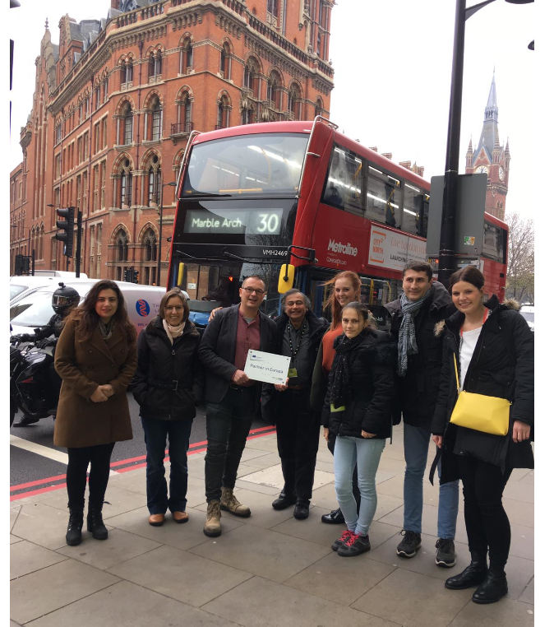

The project consortium has met for the 2nd DigI-VET – Research and Development Conference. This meeting took place between 19th and 21st of November 2019 in London (United Kingdom) being hosted by ARVET in UK.

The meeting familiarised the partners with current status of the DiGI-VET project and helps to get into a smooth working atmosphere. The Survey Study and the Online Observatory were discussed. Moreover, the Competence Profile and the structure of the DiGI-VET book were presented and the partners discussed ideas and the future work. The work plan was established and the importance of dissemination was emphasised. The financial and administrative structure of the project and its reporting were addressed and discussed.