DigI-VET
Fostering Digitization and Industry 4.0 in vocational education
2018-1-DE02-KA202-005145

DigI-VET Multiplier Event Cyprus
Event Minutes

Emphasys Centre

Project Title DigI-VET

Reference Number 2018-1-DE02-KA202-005145

Multiplier Event in Cyprus – Event Minutes
Date: 07.02.2020
Start: 08.00h
End: 12.00h
Place: Cyprus Expo, Ilia Papakiriakou, Makedonitissa Area, 2415, Engomi, Nicosia, Cyprus
Participants: 25

The DigI-VET Project- Multiplier Event
On the 7th of February 2021, Emphasys Centre participated in the International «Education and Career» Exhibition. The exhibition is in collaboration with the Ministry of Education, Culture, Sports and Youth of Cyprus, the Cyprus Chamber of Commerce and Industry (CCCI), the Cyprus Employers and Industrialists Federation (ΟΕΒ) and the European Office of Cyprus (EOC), in cooperation with the British Council Cyprus.
Emphasys was able to book two booths for the event and had a special slot booked for the DigI-VET project. After welcoming our participants, the event began with a brief presentation of our organisation and then of the DigI-VET project! The 5 Intellectual Outputs were discussed including the DigI-VET sMOOC, the DigI-VET book, the curriculum with the modules, the online observatory and finally explaining about the current situation in of Digitisation in Cyprus. For that part of the presentation a short introduction was presented, followed by the Status of Digitisation in Cyprus, then the Digital Transformation/Future Developments and a short conclusion. After a short break a second presentation was presented with entitled ‘Terms, History and Agriculture’. Agriculture is a big part of the Cypriot culture, so we believed that this was very appropriate to present to the target audience.
After the presentations, the audiences were divided to small groups, were they had the chance to see of the tasks developed for the modules and also experience some of the equipment from the Emphasys labs. This equipment included our robotics section and Virtual Reality equipment. We believed that gaining a more hands-on experience with some of the technology from Industry 4.0 would make the experience more interactive. Indeed, the VR experience was very popular and the participants were very engaged with it.
Towards the end of the session, some time was granted to the participants to access to the DigI-VET website and the Online Observatory, where all materials and results are uploaded to access freely at their own time.
The final part, to conclude the event, was left open for questions and an open discussion regarding the project, its findings or any comments the participants wanted to make.

Photos from the event
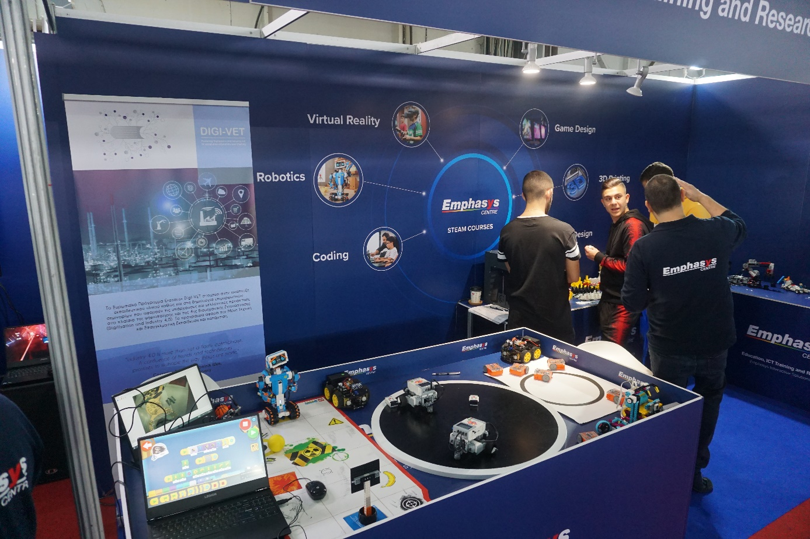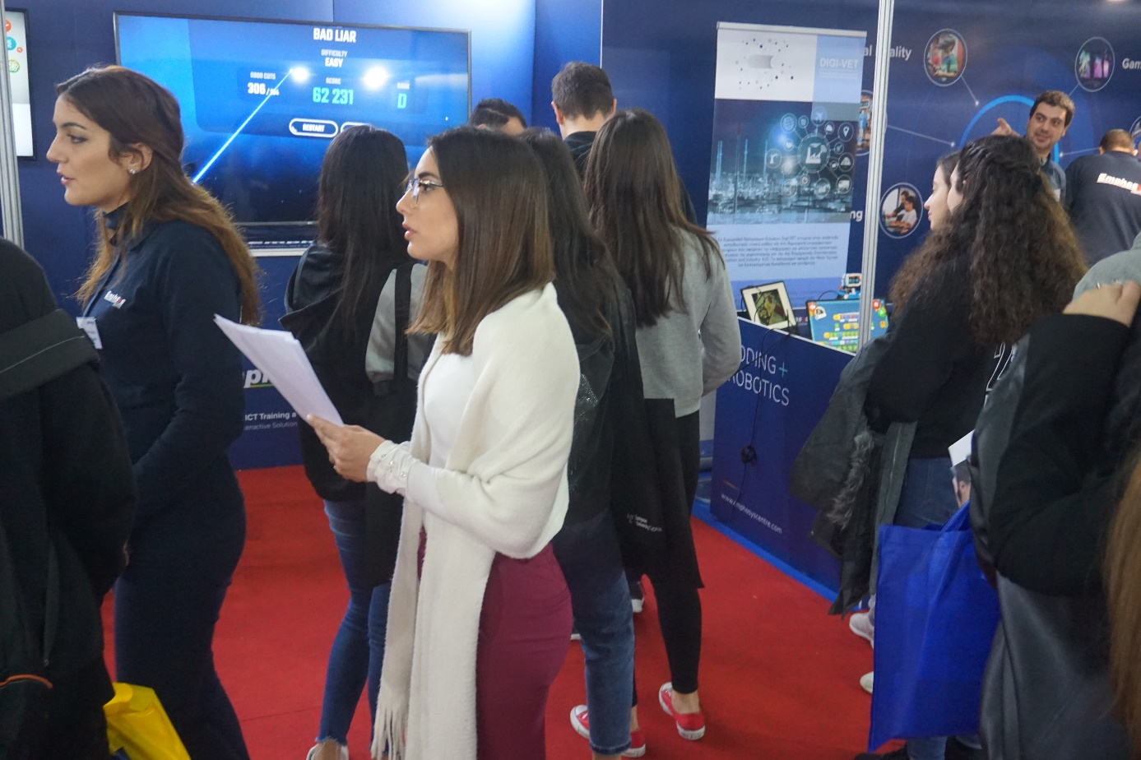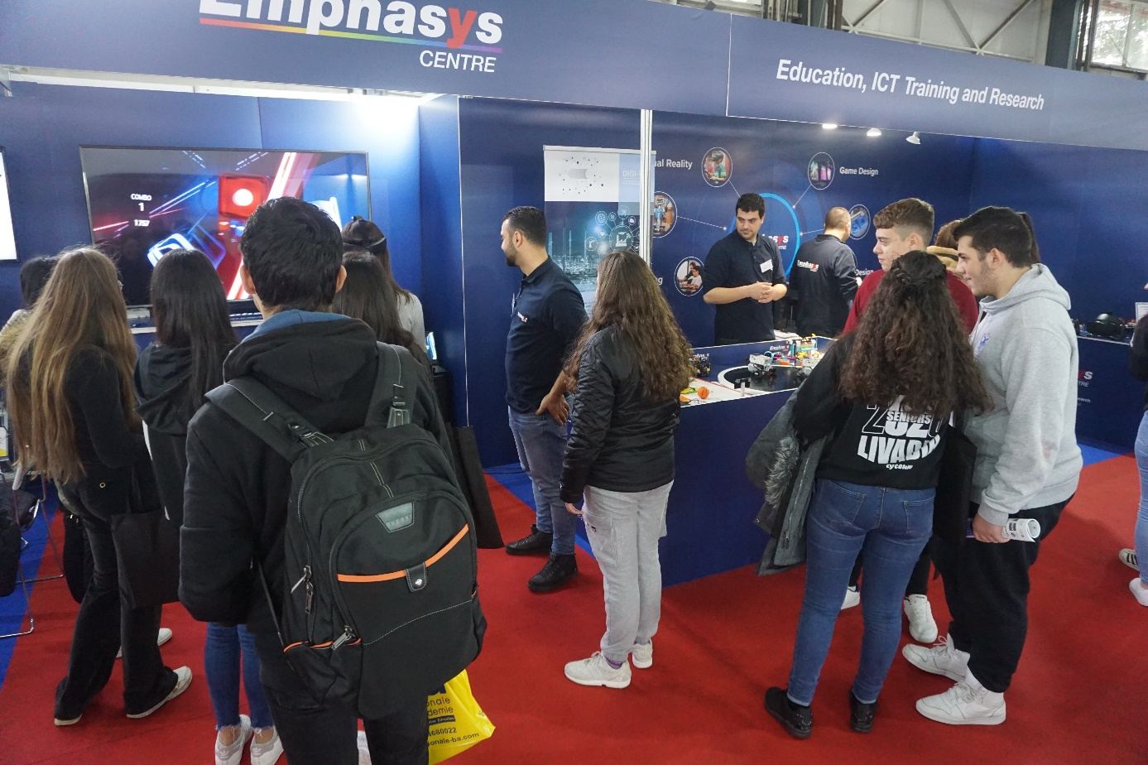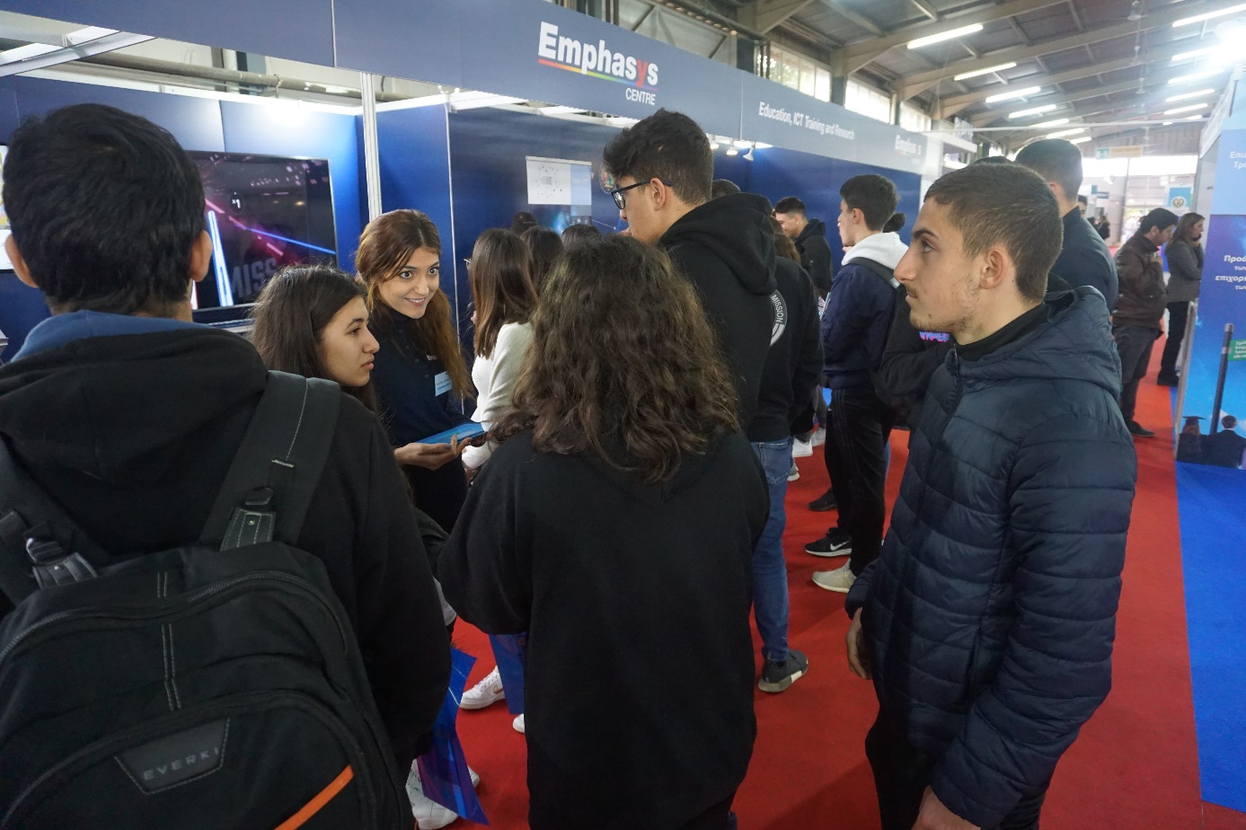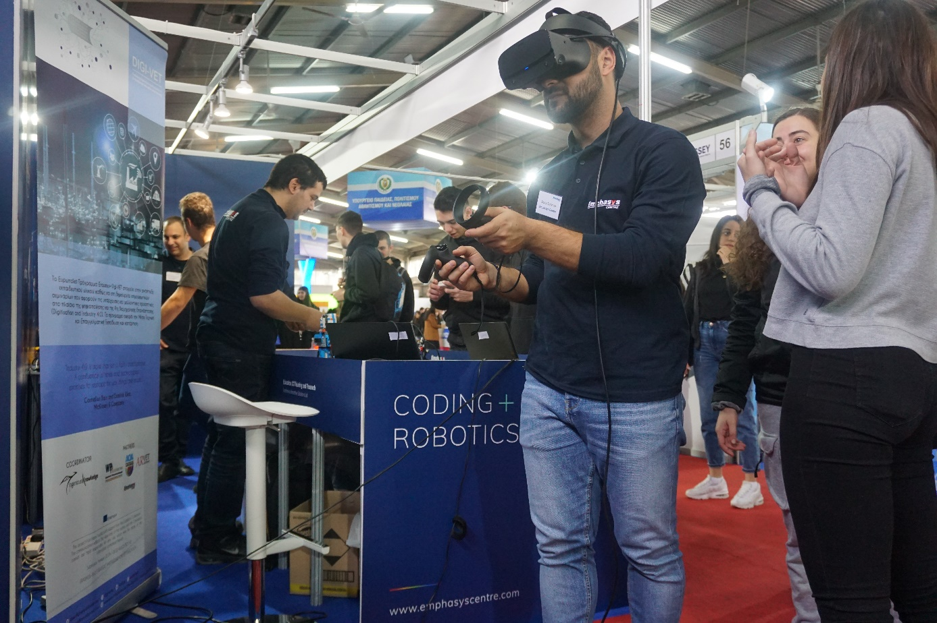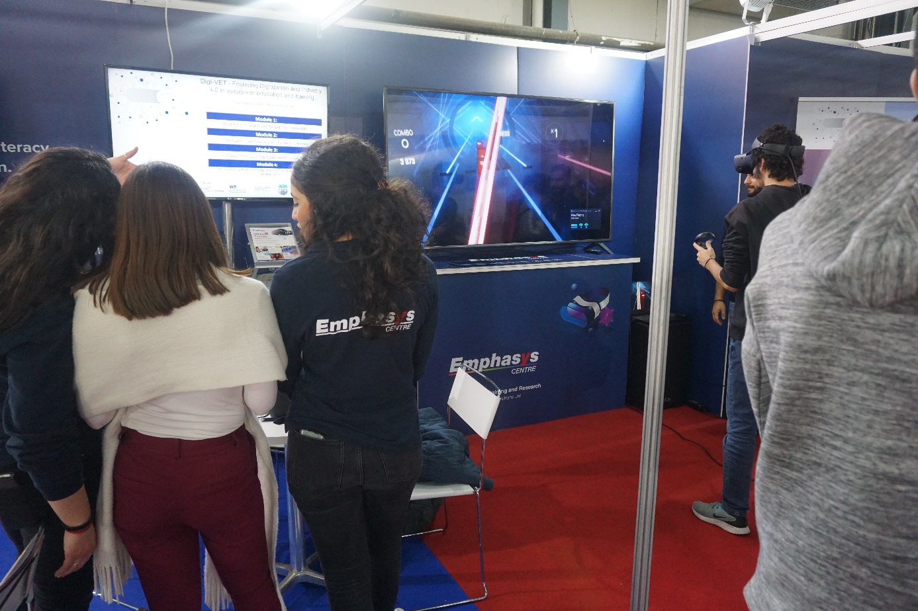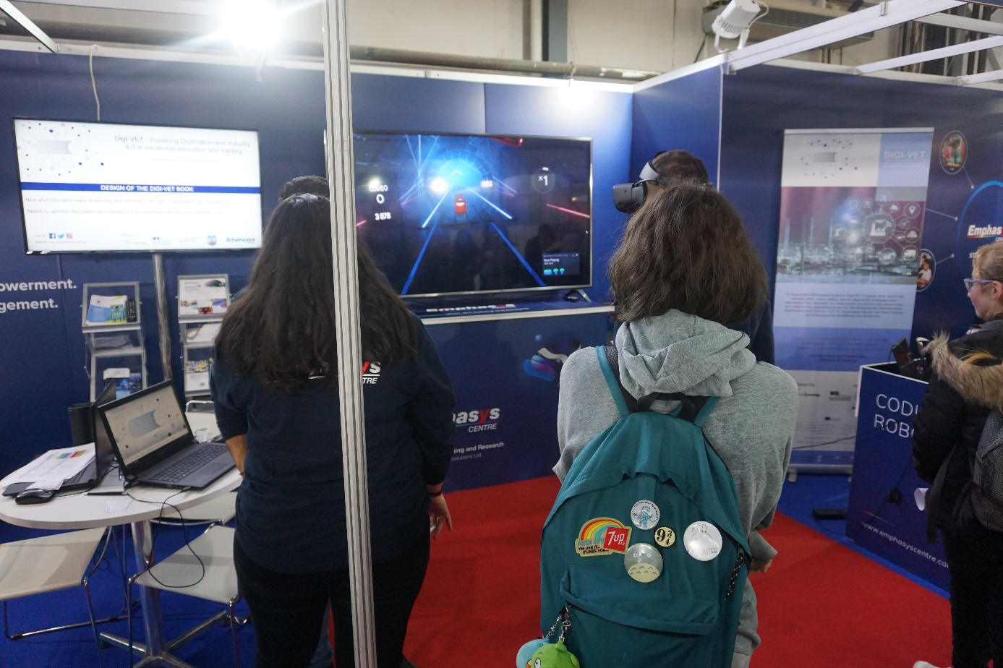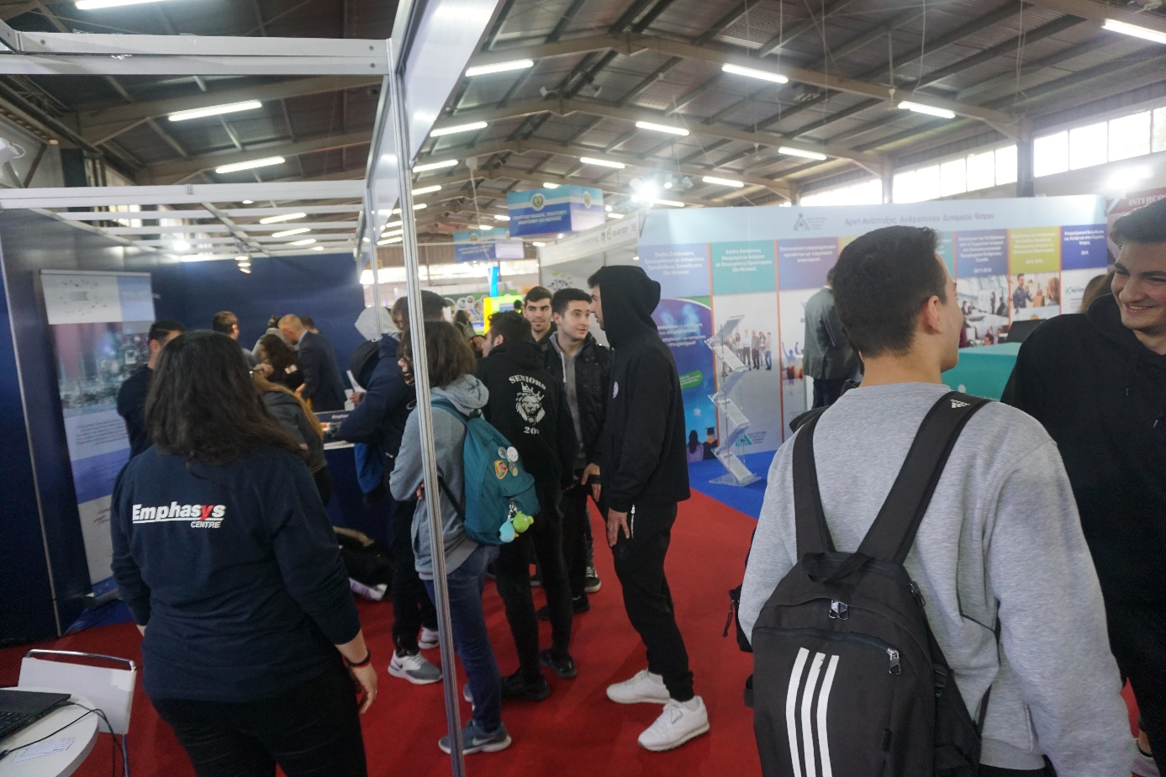

Dissemination materials
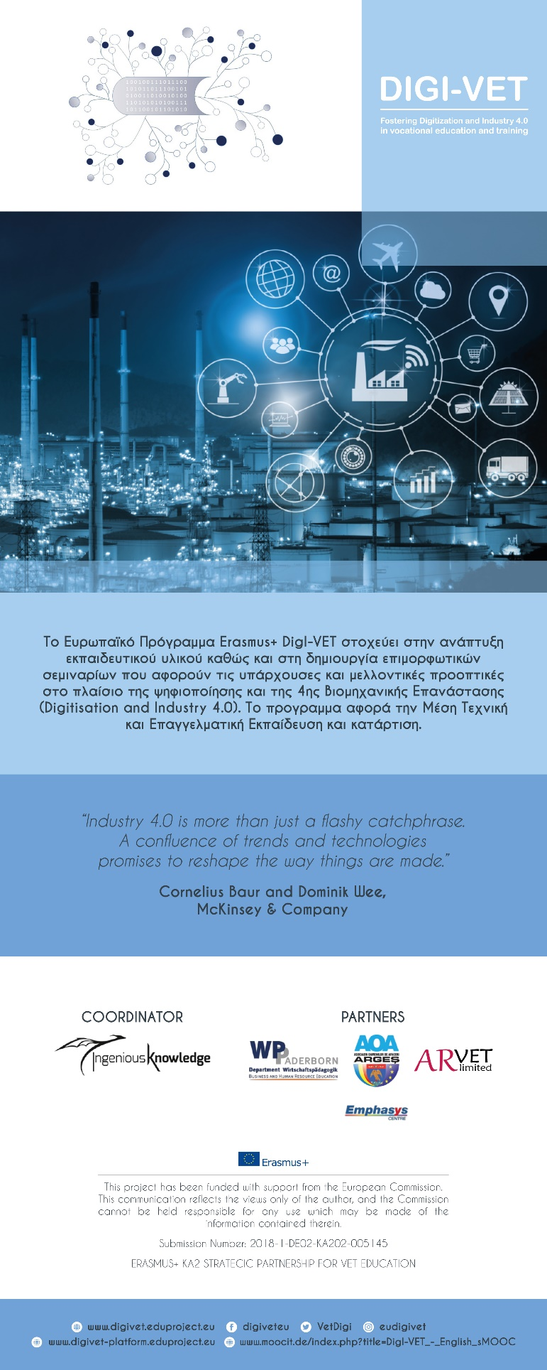
Banner

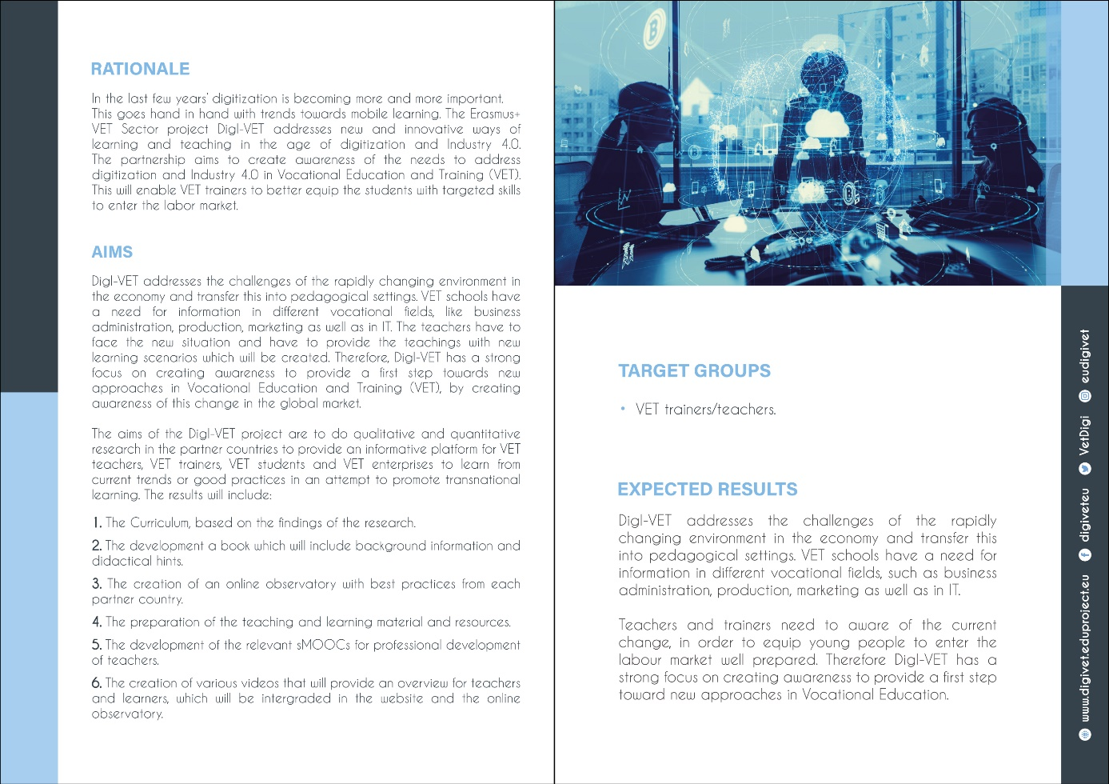
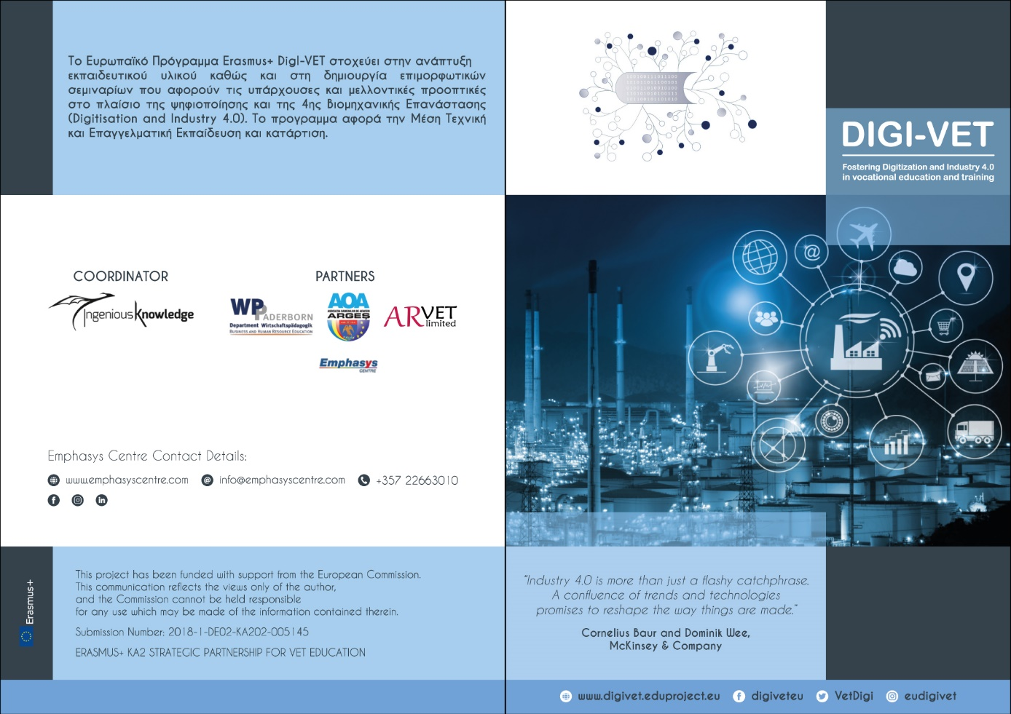
Leaflet

