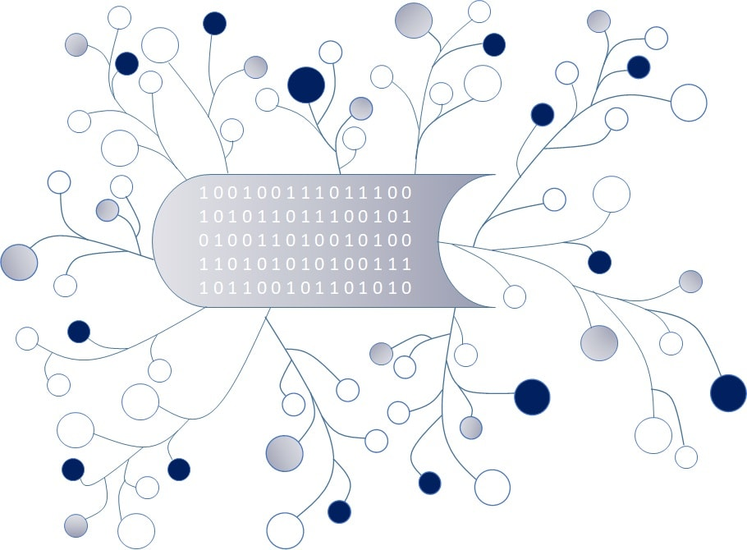

DigI-VET
Fostering Digitization and Industry 4.0 in vocational education

2018-1-DE02-KA202-005145

Research Study - Germany

September 2019
UPB – Marc Beutner

Project Title DigI-VET

Reference Number 2018-1-DE02-KA202-005145

1 Introduction
This document presents the research results of the desk-based research within digitalisation and industry 4.0. These results refer to german schools and VET. The main focus is also to show specific research to best practices, ways of dealing with digitalisation and innovative approaches to industry 4.0 in schools and VET.
In times of globalization everything is changing. There are huge changes in the economy, but also in the educational sector. One reason for that is the digitalization. Particularly in the field of education, new challenges have arisen as a result of digitisation processes (cf. Beutner 2019, p. 4; cf. KMK 2016, p. 3). Keywords such as digitization and industry 4.0 are more present than ever before (cf. Sloane et al. 2018, p. 2).
“Digitization is the process of converting analog signals or information of any form into a digital format that can be understood by computer systems or electronic devices. The term is used when converting information, like text, images or voices and sounds, into binary code. Digitized information is easier to store, access and transmit, and digitization is used by a number of consumer electronic devices” (Technopedia 2019, n. p.).
In addition to that, industry 4.0 can be defined as:
“The term industry 4.0 stands for the fourth industrial revolution, a new stage of the Organization and management of the entire value chain over the lifecycle of products. This cycle is oriented towards increasingly individualised customer wishes and extends from the idea, the order, the development and production, the delivery of a product to the end customer, to recycling, including the recycling of the product related services. The basis is the availability of all relevant information in real time through the networking of all instances involved in the creation of value and the ability to use the data to create the optimal value creation flow at the right time. By connecting people, objects and systems, dynamic, real-time-optimized and self-organizing systems are created, Cross-company value creation networks that can be optimized according to various criteria such as costs, availability and resource consumption” (Plattform Industrie 4.0 2014, p. 3).

2 Digitalisation in vocational education
These enormous changes require new tasks and demands on learners and teachers. This also requires new competences. A competence area refers to learning and teaching with new media and can be classified as digital competences. Digital competences will be presented in the following chapters in detail. Firstly, chapter 2.1 focuses on digitalisation in schools. In addition, chapter 2.2 concentrates on digitalisation in VET.

2.1 Digitalisation in schools
Digitisation requires new fields of action for teachers and learners. Within these fields of action there are huge influences. KMK defines following areas of change for schools:
- “Educational plans and teaching development, curricular developments,
- education, training and further education of educators and teachers,
- infrastructure and equipment,
- educational media, content,
- E-government, school administration programmes, education and campus management systems,
- legal and functional framework conditions “ (KMK 2016, p. 4).
Depending on the school type, digitalisation influences these areas in various measures (cf. ibid.). In the view of the huge changes, new strategies regarding the curriculum and contents of lessons have to be developed. Therefore, KMK describes two objectives:
1) All federal states in Germany include the required competences which are necessary for an active, self-determined participation into their curricula and education plans as well as framework plans. In addition to professional competencies, digital competencies are also developed. In the context of digitisation, all lessons are concerned. For this reason, all learning areas have to be adapted to digitisation processes. In this respect, the integration of the digital world is essential (cf. KMK 2016, p. 6).
2) An adapted design of lessons leads to more freedom for learner´s individualisation. Besides, learners will get the possibility for taking personal responsibility (cf. Sloane et al. 2018, p. 2). Furthermore, digital learning environments help students to become part of a team and to organise, to develop solutions together, to provide feedback. All in all, the students get more responsibility for designing their own learning process and transferring their knowledge to practical situations (cf. KMK 2016, pp. 6-7).
Based on these, the construct of digital competence develops as an important role within school education.
KMK defines six fields of competences for “competences in the digital world” (KMK 2016, p. 10):
1) Searching, Processing and Storage
2) Communication and Collaboration
3) Production and Presentation

4) Protection and Safety
5) Problem solving
6) Analysis and Reflection (cf. KMK 2016, pp. 10).

2.2 Digitalisation in VET
DigComp 2.1 and DigCompEdu publish a research study and presents a digital competence framework for vocational education (cf. DigComp 2.1 2017; cf. DigCompEdu 2018b). The following illustration shall give a closer look within this framework:
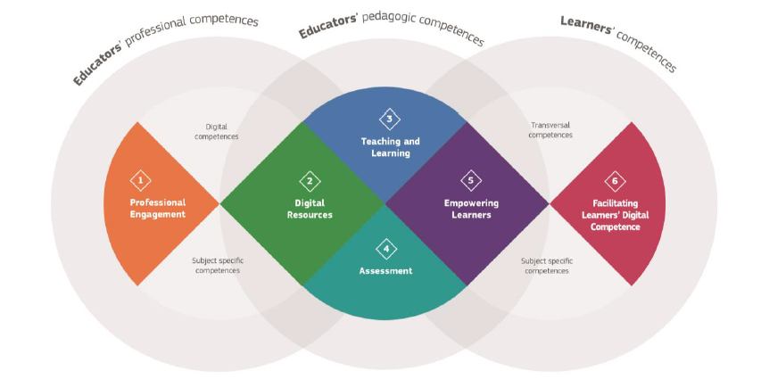

Figure 1: Digital Competence Framework
Source: DigCompEdu (2018b, p. 1).

“The DigCompEdu framework aims to capture […] educator-specific digital competences. The framework is directed towards educators at all levels of education, from early childhood to higher and adult education, including general and vocational training, special needs education, and non-formal learning contexts. It aims to provide a general reference frame for developers of Digital Competence models, i.e. Member States, regional governments, national and regional agencies, educational organisations themselves, and public or private professional training providers” (DigCompEdu 2018b, p. 1).
In general, there are six competence areas. These areas are also divided into 22 sub competences.
- Area 1) Professional engagement: “focuses on the professional environment” (DigCompEdu 2018b, p. 1)
- Area 2) Digital Resources: focusses “on sourcing, creating and sharing digital resources” (ibid.)

- Area 3) Teaching and Learning: focusses “on managing and orchestrating the use of digital tools in teaching and learning” (ibid.)
- Area 4) Assessment: focusses “on digital tools and strategies to enhance assessment” (ibid.)
- Area 5) Empowering Learners: focusses “on the use of digital tools to empower learners” (ibid.)
- Area 6) Facilitating Learners' Digital Competence: focusses “on facilitating learners' digital competence” (ibid.).
For more details, please have a closer look into the research study: https://ec.europa.eu/jrc/sites/jrcsh/files/digcompedu_leaflet_en-2017-10-09.pdf.
Within digital processes in VET, the trainer have to be focused. For trainers digitalisation means that they “develop digital competences", on the other hand they should not lose “their pedagogical impact” (Sloane et al. 2018, p. 13). In this context, pedagogic-didactical competences are more important than ever before (ibid.). Regarding digitisation processes, pedagogical competences have to be developed among trainers and learners. Sloane et al. pointed out that there is a need for further training in relation to the didactic-conceptual abilities of the trainers. They have to learn to use digital media in lesson or training in the company. Therefore, the openness of the curricula is a challenge for the trainers because they have to decide when new media can be used in a meaningful way. Furthermore, they have to deal with questions such as “In which way new media supports learning contents?”, “What kind of media should I use?” (cf. ibid, pp. 13f.).
In addition to training personnel, companies are also responding to digital change and industry 4.0. Besides, there are differences between the branches. The FGW (Forschungsinstitut für gesellschaftliche Weiterentwicklung e.V) has researched on this topic in 2018 (cf. Matuschek / Kleemann / Haipeter 2018).
“The explorative empirical study focuses on the active role of employees in the implementation of digital, ‘Industry 4.0’ technologies in industrial production. […]. Moreover, the empirical access via single cases of the implementation of Industry 4.0 solutions allows for tentative diagnoses also on the general development of Industry 4.0 in the respective industries” (ibid., p. ii).
For instance, in the chemical industry digital processes are steadily increasing. Nevertheless, they support human work. In this industry, it is not possible to replace people by digitisation because a very high level of expertise is required (cf. ibid., pp. 27ff.).
In contrast, the automotive industry is in a state of upheaval. Due to a high degree of automation processes in production, more and more jobs will be cut. Human labor is being replaced by digitization. On the other hand, the

technical demands on work tasks are increasing, because work processes, especially in the electrical industry, are becoming more and more complex (cf. ibid., pp. 35ff.).
In summary, these results show that digital competences are necessary and need to be continuously developed by all employees and learners. The next chapter 2.3 will give some insights into best practices of different apprenticeships in different sectors.

2.3 Best practices
BMBF and BiBB publish a research study, which is called “Fachkräftequalifikationen und Kompetenzen in der digitalisierten Arbeit von morgen im Kontext von Berufsbildung 4.0“ in the year 2018 and present digital processes in different apprenticeships within the vocational education (cf. BMBF / BiBB 2018). In the further course of this research report, a short overview will give a closer look into best practices. Therefore, three selected apprenticeships will presented (cf. BMF / BiBB 2018, pp. 9ff.):
Industrial clerk:
Requirements/ changes regarding work tasks, e.g.:
- IT know-how: using digital media, understanding digital processes and dependencies in the system
- Project work: from supporting project assistant tasks to independent planning and carry out projects
- Data handling: management of large amounts of data
- Increased importance of social skills and communication skills, increasing demands on self-competence, such as flexibility, discipline and self-confidence
Media designer:
Requirements/ changes regarding work tasks, e.g.:
- Complexity in digital and print media production
- The digital production, the workflows are nearly digitized. There are more and more interfaces with the IT professions.
- Many processes are automated, such as data verification processes
- Global networked production is already possible today. Working in clouds enables parallel and time-decoupled activities.
- Diversification of digital and print media products
- shorter innovation cycles
- Increased importance of Visual Effects
- Aesthetic demands have changed: more target group orientation, more effects etc.

Machinery and plant operator:
Requirements/ changes regarding work tasks, e.g.:
- Trends regarding digitisation: Networking of production systems (M2M), digital printing, Mobile assistance systems, simulation software, 3D printing of spare parts etc.
- This job profile should be preserved. It won´t be replaced due to the digitization
- fine motor activities cannot be replaced by robots

3 Digital Competence
The following competence profile is the result of this desktop research about needed competences in the field of digitisation in enterprises and education.
The figure below illustrates the research results graphically:
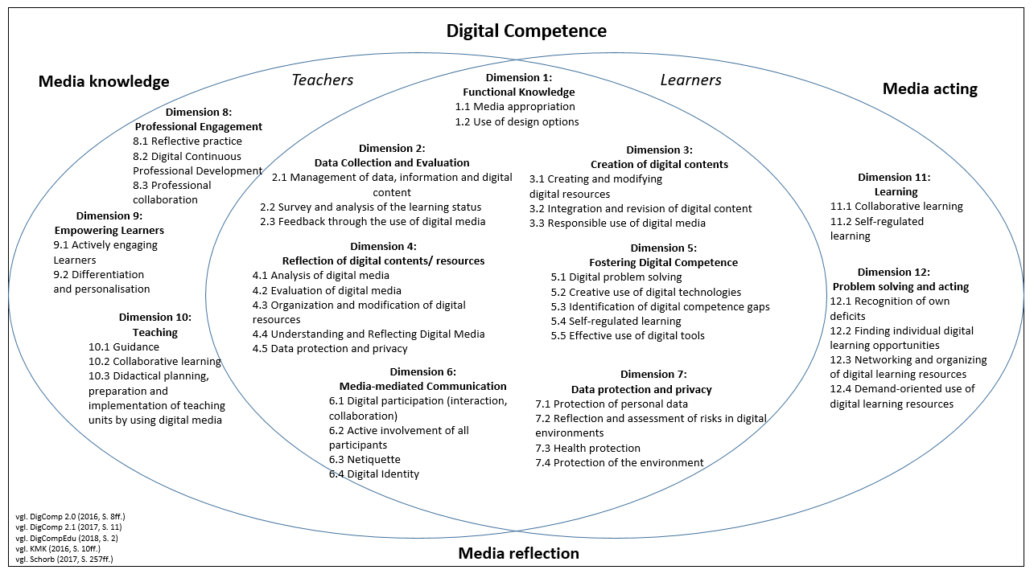
Figure 2: Digital Competence for learners and teachers
(Source: Own representation according to DigComp 2.0 (2016, pp. 8ff.); DigComp 2.1 (2017, p. 11); DigCompEdu (2018a, p. 2); DigCompEdu (2018b, p. 2); KMK (2016, pp. 10ff.); Schorb (2017, pp. 257ff.)).

The figure shows the competence profile in the field of digitization. Under the roof of digital competence, the media knowledge, the media acting and the media reflection are located (cf. SCHORB 2017, p. 257ff.). These three types are the fundamental elements of the construct of digital competence. These elements form the framework of digital competences (cf. ibid.). These include in total 11 dimensions, which consists of further sub dimensions (see figure 2). Moreover, you can see that some dimensions are only for teachers or learners. There is also an intersection. In detail, it means that some dimensions of digital competences apply for both target groups. The following tables provide a detailed overview of all digital competences needed by teachers and learners based on the research results within this report:
- Media Knowledge
Dimension | Sub dimension | Explanations
Dimension 1:  Functional Knowledge | 1.1 Media appropriation | - Requirement for instrumental-qualificatorial skills with regard to hard- and software
 | 1.2 Use of design options | - Aesthetical design knowledge  - Knowledge of text and image processing programs  - Use and application of design options
Dimension 2:  Data Collection and Evaluation | 2.1 Management of data, information and digital content | - Analysis, comparison and critical evaluation of the credibility and reliability of data sources, information and digital content
 | 2.2 Survey and analysis of the learning status | - Review of learning success and competence acquisition  - Learning control using by digital media  - Critical analysis of learning behaviour
 | 2.3 Feedback through the use of digital media | - Giving feedback about learning success/ competence acquisition to the participants by using media
Dimension 7:  Data protection and Privacy | 7.1 Protection of personal data | - Knowledge of data protection regulations  - Respecting of personal information and privacy  - Consideration of data security  - Use of privacy statements
 | 7.2 Reflection and assessment of risks in digital environments | - Knowledge and reflection about the risks of digital environments  - Knowledge of safety precautions  - Development of protection measures
 | 7.3 Health protection | - Knowledge of addictive potential  - Protect yourself and others from potential hazards  - Health-conscious use of digital media and with a view to social well-being
 | 7.4 Protection of the environment | - Awareness of the impact of digital technologies on the environment
Table 1: Digital Competence for learners and teachers - Media knowledge (Source: Own representation according to DigComp 2.0 (2016, pp. 8ff.); DigComp 2.1 (2017, p. 11); DigCompEdu (2018a, p. 2); DigCompEdu (2018b, p. 2); KMK (2016, pp. 10ff.); Schorb (2017, pp. 257ff.)).

- Media reflection
Dimension | Sub dimensions | Explanations
Dimension 4:  Reflection of digital contents/ resources | 4.1 Analysis of digital media | - Critical analysis and evaluation of digital media  - Knowledge and critical examination of the effects of digital media
 | 4.2 Evaluation of digital media | - Critical assessment and evaluation of the content of digital (educational)-resources  - Knowledge and critical examination of the effects of digital media
 | 4.3 Organization and modification of digital resources | - Create, edit and modify digital (educational) resources (to the extent permitted by law)  - Organize the content of digital resources and make it available to other interested parties, if necessary
 | 4.4 Understanding and Reflecting Digital Media | - Critically questioning regarding digital media  - Assessment and consideration of social and ethical responsibility for oneself and others  - Knowledge of the diversity of digital media/ (educational) resources  - Knowledge of the importance of digital media in the social, societal and political context  - Knowledge, Analyse and Reflection regarding the potential of digital media, especially in the education sector
 | 4.5 Data protection and privacy | - Knowledge of open educational resources and licenses  - Creation of (open) licenses  - Sensitisation within the framework of data protection regulations
Dimension 5:  Fostering Digital Competence | 5.1 Digital problem solving | - Identification of technical problems  - Solving technical problems  - Transferring digital knowledge to new situations
 | 5.2 Creative use of digital technologies | - Use of digital tools and technologies for knowledge creation and process innovation  - To deal individually and collectively with cognitive processing in order to solve conceptual problem situations in digital environments.
 | 5.3 Identification of digital competence gaps | - Knowledge about (further) development of digital competences  - Supporting others regarding (further) development of digital competences  - Seizing opportunities to keep up with self-development and digital evolution
 | 5.4 Self-regulated learning | - Use of digital technologies to support self-regulated learning processes  - Planning, implementation, control and reflection of the individual learning process
 | 5.5 Effective use of digital tools | - Knowledge about digital tools and decisions are most effective in supporting the individual learning process
Dimension 8:  Professional Engagement | 8.1 Reflective practice | - Self-critical evaluation of digital media  - Reflection of the didactical preparation and use of digital media in coordination with practice
 | 8.2 Digital Continuous  Professional Development | - Targeted use of digital media for own development
 | 8.3 Professional collaboration | - Collaboration and active sharing of experiences with other teachers through digital media
Table 2: Digital Competence for learners and teachers - Media reflection
(Source: Own representation according to DigComp 2.0 (2016, pp. 8ff.); DigComp 2.1 (2017, p. 11); DigCompEdu (2018a, p. 2); DigCompEdu (2018b, p. 2); KMK (2016, pp. 10ff.); Schorb (2017, pp. 257ff.)).

- Media acting
Dimension | Sub dimensions | Explanation
Dimension 3:  Creation of digital contents | 3.1 Creating and modifying  digital resources | - Creation and edition of digital content in multiple formats  - Expressing yourself by digital resources
 | 3.2 Integration and revision of digital content | - Using digital media to integrate new tasks/formats/activities into the learning process in order to (further) develop digital content  - Edition, presentation and sharing of digital content
 | 3.3 Responsible use of digital media | - Knowledge of copyright and licensing laws regarding data, information and digital content  - Knowledge and compliance with legal requirements for the creation and further development of digital content  - Respecting of personal rights
Dimension 6:  Media-mediated Communication | 6.1 Digital participation (interaction, collaboration) | - Ensuring that all stakeholders have access to the digital media  - Consideration of previous knowledge of all involved parties  - Knowledge and understanding of appropriate digital means of communication for a given context  - Exchange data, information and digital content with others by using appropriate digital media  - Participation of social, public and private services by using digital media
 | 6.2 Active involvement of all participants | - Using of digital media/technologies to increase and foster the active and creative engagement of stakeholders  - Suggestions for complex problem solving processes
 | 6.3 Netiquette | - Awareness of rules of conduct with regard to the use of digital technologies and interaction in digital environments.  - Adaptation of communication strategies to the respective context  - Raising awareness of cultural and generational diversity in digital environments
 | 6.4 Digital Identity | - Development and management of digital identity  - Protection of own reputation  - Protection of data generated by multiple digital media
Dimension 9:  Empowering Learners | 9.1 Actively engaging  Learners | - Fostering the active and creative engagement of learners by using digital media.  - Fostering of deep, transversal thinking  - Dealing with complex practical issues  - Extension of teaching to real learning situations
 | 9.2 Differentiation and personalisation | - Supporting learners in their learning process in order to achieve individual learning aims at their own learning pace
Dimension 10: Teaching | 10.1 Guidance | - Support learners individually and in groups by using digital media  - Offering of innovative and new support strategies
 | 10.2 Collaborative learning | - Fostering of collaborative learning through digital media  - Preparation learners specifically for using digital media and enable them to use digital media in group work phases, so that their cooperation and communication can be strengthened
 | 10.3 Didactical planning, preparation and implementation of teaching units by using digital media | - Conscious use of digital media in the classroom  - Planning, designing and implementation of digital teaching methods
Dimension 11:  Learning | 11.1 Collaborative learning | - Using of digital tools and technologies for collaborative processes and for the development of results within group work to strengthen communicative group processes
 | 11.2 Self-regulated learning | - Using of digital media to control and support the individual learning process  - Learning progress can be documented and reviewed by using digital media  - Organisation of the individual learning process through digital media
Dimension 12:  Problem solving and acting | 12.1 Recognition of own deficits | - Identification of own deficits regarding the use of digital media  - Developing of measures/strategies to solve the deficits
 | 12.2 Finding individual digital learning opportunities | - Knowledge, assessment, use of effective digital learning environments
 | 12.3 Networking and organizing of digital learning resources | - Organization of a personal system of networking regarding digital learning resources
 | 12.3 Demand-oriented use of digital learning resources | - Knowledge of digital tools and ability to use them adapted to the respective context  - Knowledge of requirements for digital tools  - Identification of digital tools which support problem solving process
Table 3: Digital Competence for learners and teachers - Media acting
(Source: Own representation according to DigComp 2.0 (2016, pp. 8ff.); DigComp 2.1 (2017, p. 11); DigCompEdu (2018a, p. 2); DigCompEdu (2018b, p. 2); KMK (2016, pp. 10ff.); Schorb (2017, pp. 257ff.)).

Sources
Beutner, M. (2019): The MATH-Handbook. Cologne: Ingenious Knowledge Verlag.
BMBF / BiBB (2018): BMBF/BIBB Initiative Fachkräftequalifikationen und Kompetenzen in der digitalisierten Arbeit von morgen im Kontext von Berufsbildung 4.0. On the internet: https://www.bibb.de/tools/dapro/data/documents/verweise/so_78154%20Arbeitsheft-zi-tp.pdf [20.09.2019].
DigComp 2.1 (2017): The Digital Competence Framework for Citizens with eight proficiency levels and examples of use. European Commission. On the internet: http://publications. jrc.ec.europa.eu/repository/bitstream/JRC106281/web-digcomp2.1pdf_(online).pdf [20.09.2019].
DigCompEdu (2018a): Europäischer Rahmen für die Digitale Kompetenz von Lehrenden. Digitale Kompetenz Lehrender. Europäische Kommission. On the internet: https://ec.europa.eu/jrc/sites/jrcsh/files/digcompedu_leaflet_de-2018-09-21pdf.pdf [20.09.2019].
DigCompEdu (2018b): European Framework for the Digital Competence of Educators (DigCompEdu). On the internet: https://ec.europa.eu/jrc/sites/jrcsh/files/digcompedu_leaflet_en-2017-10-09.pdf [20.09.2019].
KMK (2016): Bildung in der digitalen Welt. Strategie der Kultusministerkonferenz. On the internet: https://www.kmk.org/fileadmin/ Dateien/pdf/PresseUndAktuelles/2017/Strategie_neu_2017_ datum_1. Pdf [20.09.2019].
Matuschek, I. / Kleemann, F. / Haipeter, T. (2018): Industrie 4.0 und die Arbeitsdispositionen der Beschäftigten Zum Stellenwert der Arbeitenden im Prozess der Digitalisierung der industriellen Produktion. A study of FGW – Forschungsinstitut für gesellschaftliche Weiterentwicklung e.V. On the internet: http://www.fgw-nrw.de/fileadmin/images/pdf/FGW-Studie-DvA-11-Matuschek_et_al_web.pdf [20.09.2019].
Plattform Industrie 4.0. (2014): Industrie 4.0 – Whitepaper FuE-Themen. On the internet: http://www.plattform-i40. de/sites/default/files/Whitepaper_Forschung%20Stand%203.%20April%202014_0.pdf [20.09.2019].
Schorb, B. (2017): Medienkompetenz. In: Schorb, B./ Hartung-Griemberg, A./ Dallmann, C. (Eds.). Grundbegriffe Medienpädagogik (6th ed.), München 2005, pp. 254-261.
Sloane, P. F.E./ Emmler, T./ Gössling, B./ Hagemeier, D./ Hegemann, A./ Janssen, E. (2018): Qualifizierung des beruflichen Ausbildungs- und Prüfungspersonals als Gelingensbedingung für die Berufsbildung 4.0. Zentrale Ergebnisse. September 2018. On the internet: https://www.ovm-kassel.info/wp-content/uploads/2018/09/ Qualifi.-Ausbildungspers.-4.0-Uni-Paderborn_Sloane_Zentrale-Ergebnisse.pdf [20.09.2019].
Technopedia (2019): Digitization. On the internet: https://www.techopedia.com/definition/6846/digitization [03.09.2019]

