DigI-VET –
Fostering Digitization and Industry 4.0 in Vocational Education and Training

IO1: Research on Digitalisation and Industry 4.0

Activity leading organisation:
Universität Paderborn, DE
Partner organisation writing this report:
Emphasys - Private Institute Emphasys Centre, CY
Objectives of this paper

- Find the predominant definition of digitisation and Industry 4.0 in Cyprus. Take a look at the political interest regarding digitisation and Industry 4.0 in Cyprus.
- Find a focus on digitisation and Industry 4.0. Find something you want to specialise in, so that topic can be covered in the book.

Digitalisation and Industry 4.0 in Cyprus

Industry 4.0 is commonly known as the fourth Industrial revolution. It consists of the current trend of automation and data exchange in manufacturing technologies. It includes cyber-physical systems, the Internet of things, cloud computing and cognitive computing.
The term "Industry 4.0" originates from a project in the high-tech strategy of the German government, which promotes the computerization of manufacturing.
The characteristics of this Industry are:
- The strong customization of products under the conditions of highly flexible (mass-) production.
- The required automation technology which is improved by the introduction of methods of self-optimization, self-configuration, self-diagnosis, cognition and intelligent support of workers in their increasingly complex work.

The Digital Strategy for Cyprus
Cyprus does not have any major Digitalisation and Industry 4.0 examples, but its digital strategy created by the government (for the period 2012-2020) has led to imply that there is potential for the future of this industrial revolution of the island.
The Digital Strategy for Cyprus (the national information society strategy) was approved by the Council of Ministers on 8 February 2012. The Digital Strategy is a plan for the period 2012-2020 and it adopts a holistic approach for the development of the information society in Cyprus. Based on the Digital Agenda for Europe, the stated overall vision of the Digital Strategy is: "information and communication technologies to support the development and the competitiveness of the economy, and citizen participation in the social, cultural and political domains”
The Digital Strategy for Cyprus is based upon six strategic targets:
Target 1: Broaden coverage (infrastructure rollout), expand broadband and establish regulatory framework of networks. This includes the creation of appropriate infrastructure and necessary conditions to connect the Republic of Cyprus. More specifically, it will ensure the roll-out and take-up of broadband for all, at increasing speeds, through fixed and wireless technology, promote competition in electronic communications and reduce prices of broadband services and products, connect the whole of Cyprus with high and ultra-high speed networks, address cyber threats and generally strengthen security in the digital networks, enhance the international sub-marine cable network, connecting Cyprus with Europe, Middle East and Africa.
Target 2: Modernisation of public administration and provision of more applications and services to citizens and enterprises, namely, eGovernment and eHealth services. Public Administration Reform (PAR) is considered to be a very important structural change aiming at creating a flexible, modern and productive public service for the benefit of both citizens and businesses. PAR includes horizontal and sectoral issues. As regards the horizontal/cross-cutting issues, these relate to human resource management across the Public Service. With regards to the sectoral issues, functional reviews have been completed within the civil service (Ministries and Constitutional/Independent Services) aiming at the reorganisation of structures within the various Ministries and Independent Authorities, and generally the provision of better services to businesses and citizens.
Target 3: Inclusion of all (including vulnerable groups) into digital Cyprus. Increase penetration and participation of all citizens and businesses in the digital society.
Target 4: Education and Learning - improvement of eSkills and digital literacy.
Target 5: Promotion of digital entrepreneurship.
Target 6: ICT for the environment - promotion of green ICT.

The Manufacturing Industry in Cyprus
A study performed by Deloitte Cyprus (Deloitte Cyprus is among the nation's leading professional services firms, with more than 650 professionals, operating in offices in all major cities. They provide audit, tax, consulting, and corporate finance services to public and private clients spanning multiple industries.), investigates weather the Cypriot manufacturing companies are ready to enter this digital transformation and the opportunities offered by utilising Industry 4.0.
The study suggests that companies are focusing on innovative solutions to develop their processes. Also, although companies are investing in new technologies, their focus is to enhance their employees’ digital skills in order to coexist with the new technologies. The study has also shown that companies wish to further integrate digital abilities into their production line and in the near future using data analytics to predict their customers’ behaviour. And last but not least, companies aspire to introduce digital features during the sale phase.
Cyprus has always relied on trade for the development of its economy, due its strategic position at the crossroads of Europe, Asia and Africa, facilitating the access of the island’s main industrial products (such as pharmaceuticals, food and beverages, clothes, minerals, machinery and equipment) to international markets. In Cyprus, there are 5.300 manufacturers, the majority of which are small and medium sized, mostly family owned. Most manufacturing companies have less than ten employees and only seven are large, i.e. employ more than 249 people. Following the global technological trends, there have been efforts at a national level, to modernize the country’s traditional industry base.
Taking into account the fact that manufacturing, along with tourism, has been one of the main drivers of development of the Cypriot economy. Nonetheless, during the last few years, and especially after the major financial recession of 2013, the manufacturing industry has been facing competitiveness problems, mainly due to its low volume of manufacturing exports and its “traditional” production processes.
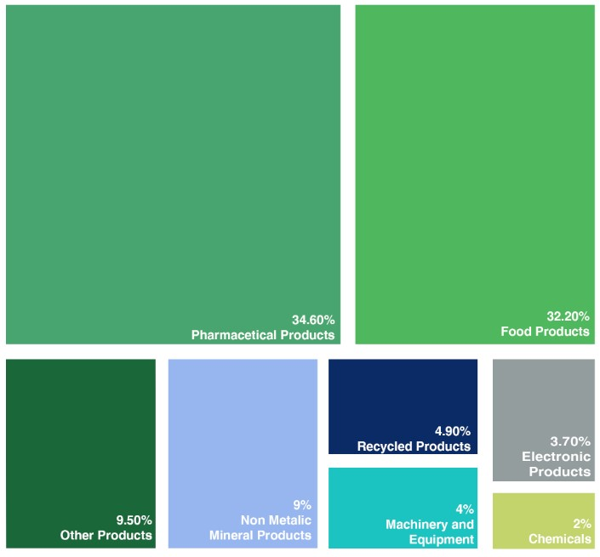The main growth areas in manufacturing in Cyprus, have been in the ICT sector, manufacturing parts, instruments and electronics, as well as consumer products such as cosmetics. Some of the most well-known export industries are those of the production of pharmaceuticals, cement and fabricated metal items.

Figure 1: Cyprus exports of industrial products (% of total), 2016
Source: Statistical Service of Cyprus
On the one hand, Cyprus’ rankings on overall production process sophistication are very low according to the statistical service of Cyprus and the Global Competitiveness Report. The same report ranks Cyprus 55th out of 137 countries and is considered a moderate innovator ranking the island below the EU average.
On the other hand, Cyprus’ research systems and human resources, with the number of new PhD graduates showing a huge increase (Statistical Service of Cyprus), as seen in the graph below.
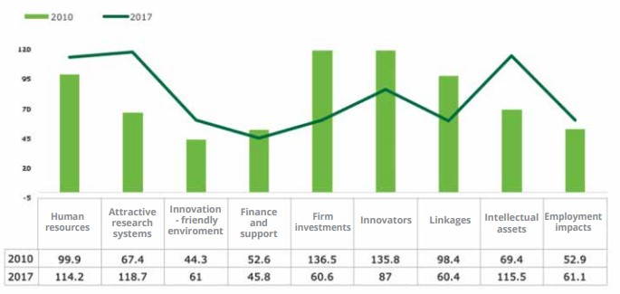
Figure 2: Cyprus European Innovation Scoreboard 2018
Source: Statistical Service of Cyprus

Problems faced by Industry 4.0 and future plans
As mentioned above, Cyprus is below the EU average as the Industry suffers from deindustrialization, poor performance and limited improvement. More specifically it scored very low in the following such as productivity per working hour, productivity per worker in Industry, knowledge-intensive exports, Research, Development & Innovation in Business. Also, gross value of the Industry as a percentage of total Gross Value, number of tertiary graduates in mathematics, science and technology in proportion of the population aged 20-29, electricity costs, internet speeds, business environment and finally, legal and institutional framework.
In order to catch up with the global market, the Cypriot government intends to focus on improving the entrepreneurial and industrial infrastructure of the island. The objective is to create a supportive ecosystem, in which businesses can collaborate and interact with each other through a group of stakeholders, like other businesses, the state, the academic community, the RPF (Research Promotion Foundation) and investors.
The RPF manages a specific scheme that finances the costs of businesses to secure patents for specific products and activities, while the Ministry of Energy, Commerce, Industry and Tourism (MECIT) has introduced a subsidy scheme for business innovation.
The Scheme provides support to existing and newly established companies looking to invest in research and innovation to develop competitive innovative products and services and implement innovative production processes.
In order to support the manufacturing industry, MECIT offers grants aiming to incentivize businesses to upgrade and/or modernize their production units, giving priority to enterprises that use local raw materials, create new jobs, are focused on exporting, are looking to modernize their processes and/or procedures in order to become more competitive on the foreign and domestic markets and produce innovative or high value-added products.
Cyprus aspires to promote industrial production in order for it to reach 15% of GDP (Gross Domestic Product) by 2030, from 7,9% in 2017. However, it is currently lagging far behind the EU average on key aspects such as gross value, productivity, exports, R&D innovation, number of higher education graduates in the fields of science and technology, cost of electricity, the environment, and the legal and institutional framework.
MECIT anticipates that the main challenge will not only be to solve the problems that concern the industry, but to also move towards further industrialization (digitization and development) through the introduction of Industry 4.0 elements.
In 2018, in an effort to support the manufacturing industry and facilitate the access to niche markets, reversing thus, the negative growth of the manufacturing industry, MECIT announced the launch of a long term industrial strategy policy for Cyprus. The goal of the Strategy is to enable the creation of a competitive and sustainable manufacturing industry, which will be focused on the production of high added value products and on improving the human resources’ skills and technical know-how in order to double the industry’s share of GDP by 2030.
The strategic objectives of the new industrial policy are to Increase competitiveness in new and existing sectors through innovation and investment in modern technologies, to enhance the extroversion of Cypriot industries. Also to increase the efficiency of the workforce and improve know-how/skills, develop a supportive infrastructure (in terms of energy, transport, etc.) and spatial planning policy that will support competitiveness. Cyprus’ economic turnaround since the 2013 crisis proves, not only that the island has a resilient economy, but also that it is able to adjust to continuously changing market needs and expectations. It is expected that the manufacturing sector will follow this trend and further expand in the near future, spurred by robust governmental incentives and a focus on high-tech products.
The island’s conducive business regulations, its strategic location connecting the EU with Middle East, North Africa and Asia, in combination with the country’s highly educated English speaking population, can greatly assist Cyprus to expand its manufacturing industry.

Looking further into Manufacturing in Industry 4.0

Industry 4.0 seems to be the biggest shift to hit global manufacturing since automation. Centred around advanced robotics and automation, new ways of human-machine interaction and huge amounts of data and boosted connectivity, Industry 4.0 is poised to modernize manufacturing and boost western industrial competitiveness.

Internet of Things (IoT)
Industry 4.0 alongside IoT offers manufacturers the ability to collect, analyse, and act on vast stockpiles of data and then set those actions in motion with highly efficient, automated robotics. The result of this is higher quality products at a lower operating cost.
The number of smart devices and amount of data captured, analysed, and stored grows, connectivity and communication is said to become more important. Both within the enterprise and to third-party partners, companies will need their data to be shareable and compatible to enable a higher level of operation.
The Declan director of Deskera (Keir-Saks) claims that IoT is the link between the rough insights provided by high tech solutions to collaborate into a clear, enterprise-level vision for modern manufacturers.
"IoT manufacturing enables virtual tracking of capital assets, processes, resources and products," Keir-Saks said. "This gives enterprises full visibility, which streamlines business processes and optimizes supply and demand."
If executed correctly, the work force behind this will be well-prepared with more and better information, automated processes and the ability to intervene on a predictive and/or precautionary basis to avoid downtime or any other issues that might affect the production output.

Artificial intelligence (AI) and machine learning
For people, it is not easy to practically analyse the information delivered by sensors and IoT-driven, so this where AI and machine learning algorithms can help. They are able to contextualize the data and spot anomalies or make recommendations.
Co-founder and chief data scientist at Flutura Decision Sciences and Analytics Derick Jose said "[AI and machine learning] can help detect early warning signals of assets becoming unhealthy, for example, top-drive RPM temperature anomalies could be the signature of an impending breakdown. Moreover, AI serves to improve efficiency in the overall operation”.
AI is especially useful when it comes to consuming the massive flows of information captured by sensors and IoT-enabled devices. Those huge amounts of data would be nearly impossible for a human operator to contextualize, so allowing computers to do it actually makes that data valuable.

Mixed reality
Mixed reality is also a major component of Industry 4.0. Big companies are already issuing mixed reality devices like helmets and glasses to employees to increase communication and visualization of contextualized data that will boost productivity and intelligent decision-making.
Tim Lynch, CEO of Psychsoftpc, said that "Mixed reality is a real game-changer in manufacturing. For repair personnel, it allows them to 'see inside' the machine that needs repair or 'see through walls' to the cables and pipes behind to know exactly where to drill or cut."
Combining all the above skills with the predictive maintenance enabled by IoT and AI would mean high-tech success rate.
For training purposes, mixed reality can create an environment where employees can experience virtual situations relevant to their job without risking actual equipment or manufacturing uptime.
"In training, workers can practice on virtual products to gain experience that will carry over to the real world," Lynch said. "They can be put in simulated situations that they could face in doing their job and learn how to handle them virtually before being exposed to them at work."

3D printing
3D printers have been around since 1983, though were often only in the hands of large companies. Today, they can be purchased and be used by just about anyone. 3D printers are also used in low-volume manufacturing to test products.
Doug Collins, owner of Avid 3D Printing, said: "When small companies develop new products and need to make 50 parts to test, or just to bring to a trade show, tooling up for traditional manufacturing can be very expensive. They might not have the capital to tackle traditional manufacturing. 3D printers allow low-volume production without as much investment so they can save that capital for the other important stuff, like marketing."
The advantages of Manufacturing in Industry 4.0

Amongst other things, upgrading to Industry 4.0 requires a major investment. Smaller businesses would be more affordable, but for larger businesses it would be a lot higher. But the expected payoff for connected, smart devices and an automated production process would have a huge return.
These software systems would do a lot more than trade data. They would eliminate much of the human intervention. This industrial revolution of automation which includes utilizing big data, analytics and artificial intelligence, is one of the most important drivers behind digital manufacturing and Industry 4.0.
Some of the advantages include:
Increased competitiveness. Outsourcing to lower-income regions of the world was previously vital for manufacturers wanting to remain competitive, with Industry 4.0 this could change. It could result to manufacturers can choosing locations based on "technical capabilities and proximity to consumer demand, rather than decisions driven primarily by wages" - According to Ramaswami.
Increased productivity. Automation, analytics and machine-learning algorithms have taken away a lot of hands of human operators. This would mean quicker and more efficient production, with people primarily monitoring and maintaining systems.
Increased revenue and profitability. Industry 4.0 wont only create a more efficient and higher quality production process, but it will enable things like predictive and preventive maintenance and upgrades, which would result in lower downtime and less capital spending.
Manufacturing process optimization. With even more connectivity, shared data and better analytics, closer collaboration along the entire supply chain, could lead to increased efficiency, optimization and innovation in the long run across the manufacturing industry.
Seamless record-keeping and traceability. The vast capture and analysis of data also means better record archiving and search capabilities. This has consequences from government regulatory compliance to customer satisfaction.
Despite these advantages, the shift is still in the early stage. Only 6 percent of manufacturers are considered "digital masters" that have reached an advanced stage in digitizing the production process.
It is estimated that 76 percent of manufacturers already have a smart factory initiative in the works or currently under formulation. What is for sure is that Industry 4.0 and advanced digital technologies will soon become the norm for manufacturing worldwide. Those that adopt early will have an advantage.

References:

https://www2.deloitte.com/content/dam/Deloitte/cy/Documents/innovation-and-entrepreneurship-%20centre/Industry%204.0%20readiness%20report%202019.pdf
https://www2.deloitte.com/cy/en/pages/about-deloitte/articles/Industry-4-0-readiness-report.html?utm_source=Mondaq&utm_medium=syndication&utm_campaign=View-Original
https://www2.deloitte.com/cy/en/pages/about-deloitte/articles/industry-4-0.html#
file://192.168.0.250/Emphasys%20Projects/Emphasys/EUROPEAN%20PROJECTS%20KA2/VET%20SECTOR/DigI-VET/IOs/IO1/Research%20IO1/CY_IEC_Industry4.0_Noexp.pdf
http://www.mondaq.com/cyprus/x/770932/Industry+Updates+Analysis/Industry+40+readiness+report
http://www.mcit.gov.cy/mcit/sit/sit.nsf/All/FBC207AE9BC8BE69C225819C0040030F?OpenDocument
https://www.cyprusprofile.com/en/sectors/manufacturing-and-industry/
http://www.cystat.gov.cy/mof/cystat/statistics.nsf/index_gr/index_gr?OpenDocument
https://www.businessnewsdaily.com/10156-industry-manufacturing-iot.html

Statistical Service (2017) Business Registry, 2016. Available at: http://www.mof.gov.cy/mof/cystat/statistics.nsf/All/8A220DD4941EDCA9C225803500304320/$file/ ENTERPRISES_NACE2_SIZE-2016-16117.pdf?OpenElement
Available at: http://www3.weforum.org/docs/GCR2017-2018/05FullReport/ TheGlobalCompetitivenessReport2017%E2%80%932018.pdf

