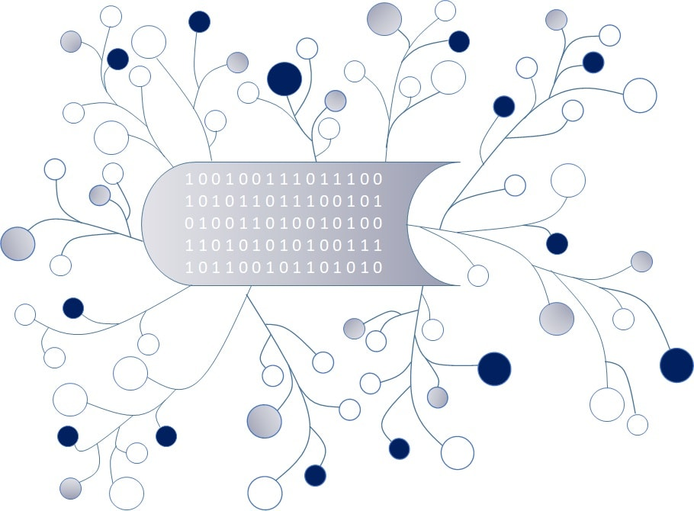
DigI-VET
Fostering Digitization and Industry 4.0 in vocational education

2018-1-DE02-KA202-005145

Questionnaire for
DigI-VET

May 2019
UPB – Marc Beutner

Project Title DigI-VET

Reference Number 2018-1-DE02-KA202-005145

Dear Participant,
We are very happy that you take your time to complete this questionnaire about digitisation and industry 4.0. In the ERASMUS+ project DiGI-VET we are focusing on new developments in digitisation within the European union and its member states. The core idea is to get information on the current situation, on challenges and changes as well as on future perspectives. Therefore, it is important to get an impression how people in the countries of Europe think about this field and the developments in it.
So, it is interesting to get information how you think about these aspects.
Here are some orientations:

General instructions for completing the questionnaire:
This questionnaire consists of a quantitative and qualitative parts and addresses three thematic sections:
- General information
- Estimations about digitisation and industry 4.0
- Opportunities and Challenges

To handle all questions, you need approximately 15 minutes.
All your information will be analysed and evaluated completely anonymously.
For any further questions we are at your disposal. You can reach us via our email address:
Marc.Beutner@uni-paderborn.de

General Information

Gender – I am …

Female
Male
Rather not say
Other / Diverse

Age

Below 20
21-30
31-40
41-50
51-60
Over 60

Status – I am …

a trainer/teacher
a student/learner
a staff member of the Human Resources Management
a business/company owner
a VET-expert
an Educational and Career Counsellor
I am another type of educational expert
Other

Status – I am active …

at a primary school
at a secondary school
at a vocational school
at a VET provider
at a university
at another educational institution
at a company
at the government
at a teacher association
at a chamber
at an employers association
at a trade union / employees association
Other

Estimations about digitization and industry 4.0

Do you agree to the following statements about definitions of digitisation

 | strongly  agree | agree | disagree | strongly disagree
Digitisation is the process of converting information into a digital (i.e. computer-readable) format.
Digitisation is the process of converting economic processes from an analog to a digital way of work. |  |  |  | 2
Digitisation is the process of digital change in society and the digital transformation which is recognized as the digital revolution.
Digitisation the digital modification of instruments and tools.
Digitisation means to compress data lossless or lossy.
Digitisation means optimisation of
Business processes using information technology.

Do you agree to the following statements about digitisation challenges.

 | strongly  agree | agree | disagree | strongly disagree
Digitisation is a process which challenges society.
Digitisation is a process which challenges enterprises / company
Digitisation is a process which challenges everyone.

Digitisation is a process which challenges teachers/trainers
Digitisation is a process which challenges learners.

Digitisation is a process which challenges VET trainers.
Digitisation is a process which challenges politics.
Digitisation is a process which challenges economy.

Do you agree to the following statements about the essential focus of digitisation.

 | strongly  agree | agree | disagree | strongly disagree
Digitisation focusses essentially on data security and privacy.
Digitisation focusses essentially on digital network infrastructure.
Digitisation focusses essentially on enhancing processes.
Digitisation focusses essentially on collecting data.
Digitisation focusses essentially on offering information.

2Do you agree to the following statements about the persons or groups which have to handle digitisation?

 | strongly  agree | agree | disagree | strongly disagree
Digitisation is a process which has to be handled by learners.
Digitisation process which has to be handled by VET-providers.
Digitisation is process which has to be handled by politicians.
Digitisation is process which has to be handled by technical experts.
Digitisation is process which has to be handled by teachers and trainers.
Digitisation is process which has to be handled by staff members in companies.
Digitisation is process which has to be handled by business leaders.

Yes
No

How important is digitisation today?
Rate with one cross on a scale from 1 to 10 (1 – unimportant to 10 – important)

1 | 2 | 3 | 4 | 5 | 6 | 7 | 8 | 9 | 10

How important will be digitisation in five years?
Rate with one cross on a scale from 1 to 10 (1 – unimportant to 10 – important)

1 | 2 | 3 | 4 | 5 | 6 | 7 | 8 | 9 | 10

How important is the change concerning industry 4.0 today?
Rate with one cross on a scale from 1 to 10 (1 – unimportant to 10 – important)

1 | 2 | 3 | 4 | 5 | 6 | 7 | 8 | 9 | 10

How important will be the change concerning industry 4.0 in five years?
Rate with one cross on a scale from 1 to 10 (1 – unimportant to 10 – important)

1 | 2 | 3 | 4 | 5 | 6 | 7 | 8 | 9 | 10

Which skills and competences are important for the digital change in society / industry 4.0?

 | very  important | important | less important | unimportant
Social competences
Communicative competences
Methodological competences
Process-related competences
Research-related competences
Subject specific competences
Practice-related competences
Managerial competences
Other, please specify:

Which skills are important for the digital change in society / industry 4.0?

 | very  important | important | less important | unimportant
Basic IT skills
Deep IT skills
Technical skills
Organisational skills
Applying theoretical knowledge
Self-awareness skills
Leadership skills
Team working skills
Planning skills
Implementation skills
Evaluation skills
Implementation skills
Ethical skills
Self-management skills
Problem solving skills
Decision Making skills
Data analysis skills
Flexibility
Patience
Other, please specify:

Tell us your opinion:
Currently, digitization is …

important |  |  |  |  |  |  | unimportant
interesting |  |  |  |  |  |  | uninteresting
motivating |  |  |  |  |  |  | demotivating
fun |  |  |  |  |  |  | boring
innovative |  |  |  |  |  |  | old-fashioned
helpful |  |  |  |  |  |  | not helpful
useful |  |  |  |  |  |  | useless
necessary |  |  |  |  |  |  | unnecessary
easy to use in teaching |  |  |  |  |  |  | hard to use in teaching
easy to use in learning |  |  |  |  |  |  | hard to use in learning

Tell us your opinion:
In five year, digitization will be …

important |  |  |  |  |  |  | unimportant
interesting |  |  |  |  |  |  | uninteresting
motivating |  |  |  |  |  |  | demotivating
fun |  |  |  |  |  |  | boring
innovative |  |  |  |  |  |  | old-fashioned
helpful |  |  |  |  |  |  | not helpful
useful |  |  |  |  |  |  | useless
necessary |  |  |  |  |  |  | unnecessary
easy to use in teaching |  |  |  |  |  |  | hard to use in teaching
easy to use in learning |  |  |  |  |  |  | hard to use in learning

Should VET teachers and VET trainers support their students with digitisation to foster their learning processes?

Yes
Rather yes
Rather no
No

Opportunities and Challenges

What are the opportunities of about digitisation and Industry 4.0?

Opportunities of digitisation

Opportunities of industry 4.0

What are the challenges of digitisation and Industry 4.0?

Challenges of digitization

Challenges of industry 4.0

Do you want to provide other comments on the topic?

