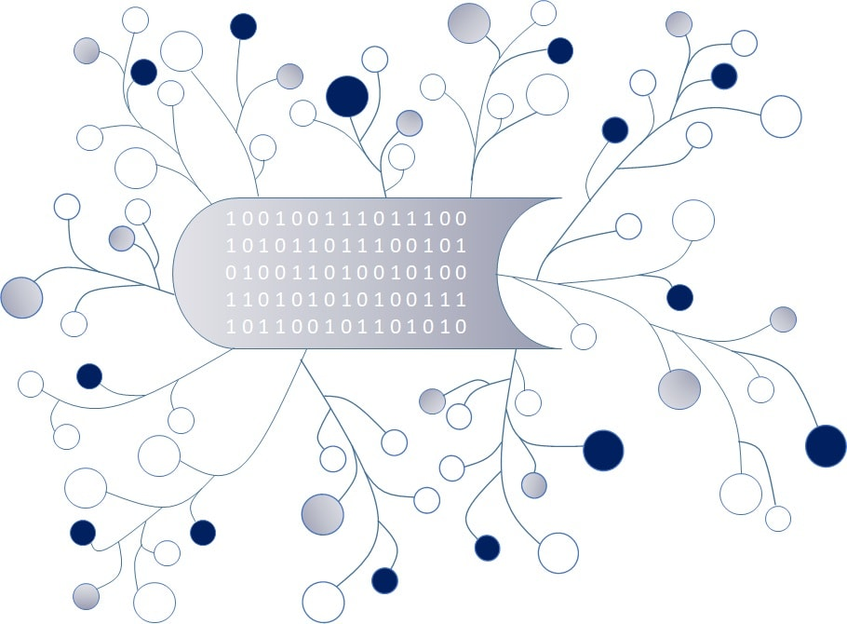

***DigI-VET***

***Fostering Digitization and Industry 4.0 in vocational education***

***2018-1-DE02-KA202-005145***

**Report**

**Questionnaire for Digi-VET**

*September 2019  
  
Asociatia Oamenilor de Afaceri Arges*

*Project Title DiGI-VET*

*Reference Number 2018-1-DE02-KA202-005145*

**CONTEXT**

|  |  |
| --- | --- |
| **Reference number** | 2018-1-DE02-KA202-005145 |
| **Programme** | Erasmus + |
| **Key action** | Cooperation for innovation and the exchange of good practices |
| **Action** | Strategic Partnerships |
| **Project acronym** | DIGI-VET |
| **Project title** | Fostering Digitization and Industry 4.0 in vocational education |
| **Project starting date** | 01/12/2018 |
| **Project duration** | 24 months |
| **Project end date** | 31/11/2020 |

**REVISION HISTORY**

|  |  |  |  |  |  |
| --- | --- | --- | --- | --- | --- |
| **Version** | **Date** | **Author** | **Description** | **Action** | **Pages** |
| 1.0 | 24/09/2019 | A.O.A. Arges | Report questionnaires | C |  |

(*) Action: C = Creation, I = Insert, U = Update, R = Replace, D = Delete

**Disclaimer**

This project has been funded by the Erasmus+ Programme of the European Union.

The information and views set out in this publication are those of the author(s) and do not necessarily reflect the official opinion of the European Union. Neither the European Union institutions and bodies nor any person acting on their behalf may be held responsible for the use which may be made of the information contained therein.

Reproduction is authorised provided the source is acknowledged.

All rights reserved

Copyright © in DigI-Vet consortium, 2018-2020

Contents

Introduction 5

About the Project 5

Survey Results 6

General information........................................................................................................................................6

Estimations about digitization and industry 4.0 .............................................................................................7

Opportunities and Challenges.......................................................................................................................11

Conclusion 11

# Introduction

In order to complete the IO1 of the project, Asociatia Oamenilor de Afaceri Arges conducted, between 15th of July – 20th of August 2019, a survey about digitization and industry 4.0 in Romania. You can find below the analysis of all answers we received, which give us an idea – through the eyes of the participants, about the current situation in our country, the challenges and changes as well as on future perspectives.

We received 100 answers from trainers/teachers, students/learners, staff members of the Human Resources Management, business/company owners, VET-experts, Educational and Career Counsellors and other types of educational experts.

# About the Project

In the last few years’ digitization is becoming more and more important. This goes hand in hand with trends towards mobile learning.

The Erasmus+ project DigI-VET addresses new and innovative ways of learning and teaching in the age of digitization and Industry 4.0. The partnership creates awareness of the needs to address digitization and Industry 4.0 in vocational education and training (VET).

The consortium will produce a DigI-VET book to create broad awareness of the topic in higher education. The purpose of it will be to ensure that the information and best practices produced are of an appropriate standard, to create awareness and provide the necessary information.

The fifteen core results of the project DigI-VET will be:

1. the DigI-VET Curriculum
2. the DigI-VET Learning and Teaching Resources
3. the DigI-VET Online Observatory with best practice information and videos
4. the DigI-VET Book on Digitisation and Industry 4.0 in European VET
5. the DigI-VET sMOOC
6. the DigI-VET research report
7. the DigI-VET dissemination materials (posters, leaflets, brochure, cards, pens, flyer)
8. the DigI-VET Website with Blog
9. the DigI-VET Checklist for VET educators and teachers
10. the DigI-VET videos (integrated in the website and the online observatory)
11. the DigI-VET OER strategy
12. the DigI-VET digitisation concept for VET
13. the DigI-VET publications, newsletter and press-articles
14. the DigI-VET sMOOC Concept
15. the DigI-VET evaluation report

# Survey Results

**General Information**



We received answers to the questionnaire from 100 people: 38 participants (38%) were male, 60 participants (60%) were female.



The ages of the groups that participate were: 29 participants (29%) were under 20 years old, 23 participants (23%) were between the ages of 21-30, 19 participants (19%) were between the ages of 31-40, 15 participants (15%) were between the ages of 41-50, 11 participants (11%) were between the ages of 51-60 and 3 participants (3%) were over 60 years.



From the 100 participants, 20% were trainers/teachers, 38% were students/learners, 2% were staff members of the Human Resources, management, 10% were business/ company owners, 5% were VET or Educational and Career Counselors and 26% declared other (but here we have 24 school teachers).



Concerning the work status, 30 participants (30%) replied in a Primary or Secondary school, 15 participants (15%) replied in a Vocational school, as VET trainers or in another Educational Institution, 10 participants (10%) replied at a university, 3% at the Camber and 27 participants (27%) replied at a company or an employers association.

**Estimations about digitization and industry 4.0**

We then asked if the participants agreed with the following statements regarding definitions of Digitisation and the results were:



Regarding digitisation being the process of converting information into a digital (i.e. computer-readable) format and digitisation being the process of converting economic processes from an analog to a digital way of work 95% from participants Strongly Agreed or agreed.



About, digitisation being the process of digital change in society and the digital transformation which is recognized as the digital revolution 45% participants Strongly agreed, 37% participants Agreed and 16% participants Disagreed.



Regarding digitisation being the digital modification of instruments and tools 76% participants Strongly agreed or Agreed, and 24% desagreed.



When asked if they agreed that digitisation means to compress data lossless, 78% participants Strongly Agreed or Agreed and 22% participants disagreed.



And finally when asked whether digitisation means optimisation of Business processes using information technology 53% participants Strongly Agreed, 39% Agreed, 8% Disagreed.

When asked about digitisation challenges, between 75 and 91% of respondents strongly agreed or agreed that digitization is a challenge for company, teachers, leaners, entire economy. And 26% disagreed that it will be a challenge to politics!!!!!!

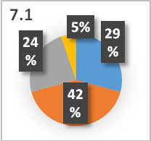 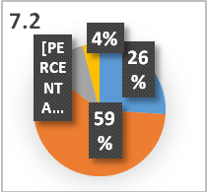 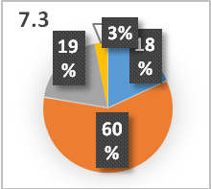 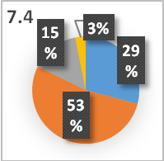 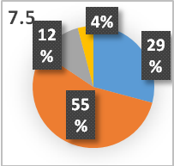 At the question about digitisation focusing essentially on data security and privacy 28 participants responded that they Strongly Agree, 40 participants that they Agree, 23 participants Disagreed and 5 participants Strongly Disagreed. Regarding digitisation focusing essentially on digital network infrastructure 25 participants agreed, 57 Agreed and 10 Disagreed. Regarding digitisation focusing essentially on enhancing processes 17 participants replied that they Strongly Agreed, 56 Agreed and 18 Disagreed. When asked if they believed that digitisation focusses essentially on collecting data 28 participants Strongly Agreed, 51 Agreed, 14 Disagreed and 3 participant Strongly Disagreed. And finally, regarding digitisation focusses essentially on offering information 28 participants Strongly Agreed, 53 participants Agreed and 11 participants Disagreed.

The participants where then asked if they agreed with the following statements about the persons or groups which have to handle digitization.



All participants Strongly Agreed or agreed that digitization is a process which has to be handled by people who know the subject in detail: technical experts 93%, VET-providers 88%, teachers and trainers 92%, staff members in companies 79%, learners 81%, business leaders 80%.

The people in which the respondents have the least confidence that they could manage this process were the politicians (see 8.3): only 17% Strongly Agreed, 39 Agreed, 32 Disagreed and 12 participant Strongly Disagreed!!

The participants were then asked if they were familiar with the term Industry 4.0, 53 participants (53%) replied Yes and 47 participants (47%) replied No.

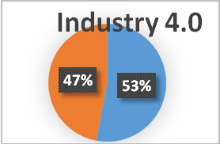

The participants were then asked to rate from a scale of 1-10 (1 – unimportant to 10 - important), how important digitisation is today and how important digitisation will be in 5 years. And also how important the change is concerning industry 4.0. and how important the change will be concerning industry 4.0 in five years. To all these

questions, the vast majority of the answers - over 85% are found in area 7-10, so important - very important. This says a lot about the importance that respondents attach to digitizing in general and the changes in industry 4.0

The participants were then asked which of the following competences are important for the digital change in society/industry 4.0. In terms of social competences 32 participants agreed that they are very important, 44 participants agreed that they are important and 15 participants thought they were less important and Unimportant 5. In terms of communicative competences, 39 participants agreed that they are very important, 48 participants that they are important and 8 participants thought they were less important and Unimportant 3. In terms of Methodological competences 34 participants replied they are very important, 48 participants replied they are important and 11 participants thought they were less important and 3 Unimportant. Regarding process-related competences 36 participants answered that they are very important, 41 as important and 13 as less important. About research-related competences 47 participants answered that they are very important, 40 as important and 10 as less or unimportant. Regarding subject specific competences, 51 participants replied as very important, 39 as important and 6 as unimportant. Concerning practice-related competences, 87 participants replied as very important or important and only 11 as unimportant. And finally, regarding managerial competences, 36 participants answered that they are very important, 44 as important and 17 as unimportant.

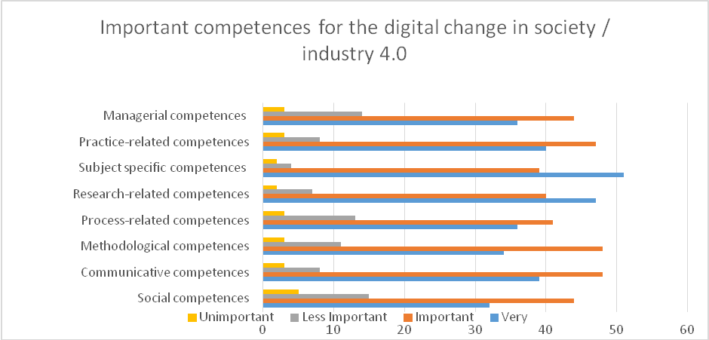

The participants were then asked which of the following skills are important for the digital change in society/industry 4.0.

Answers over 50% very important received: Basic IT skills, deep IT skills. And over 50% as important were nominated: organizational skills, implementation skills, evaluation skills, ethical skills, problem solving skills.

More than 45% as important skills received: applying theoretical knowledge, technical skills, self-awareness and self-management, team working skills, planning skills, decision making skills.

The least necessary skill has appeared leadership skills, with only 29 respondents very important and 39 important.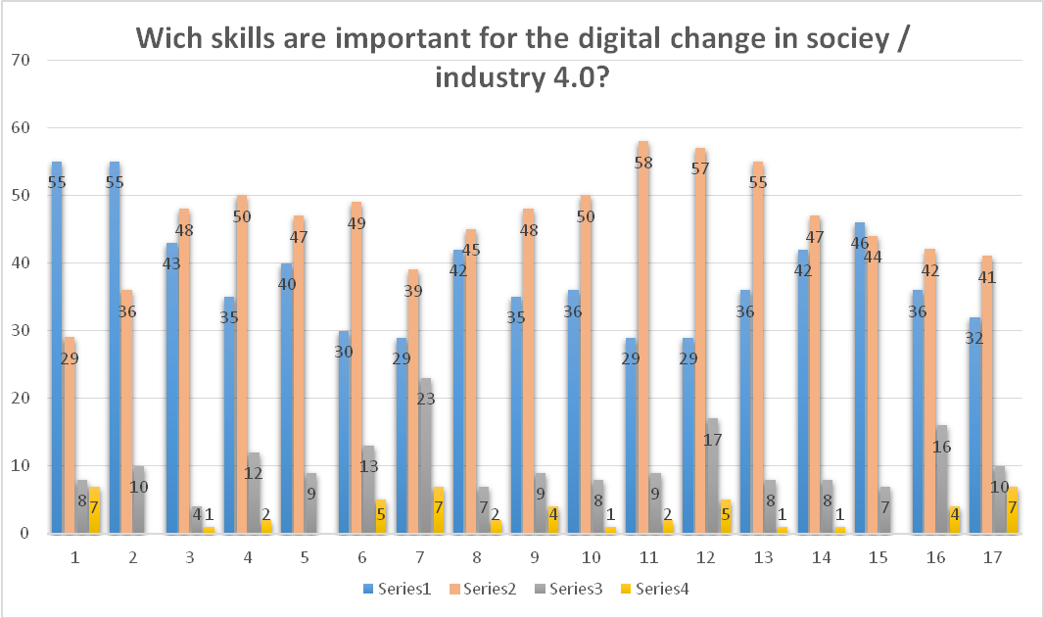

We then asked our participants to tell us their opinion on ditigitisation currently and how ditigitisation will be in 5 years, on a scale of 1 to 6 (1 being important and 6 being unimportant) the results are:

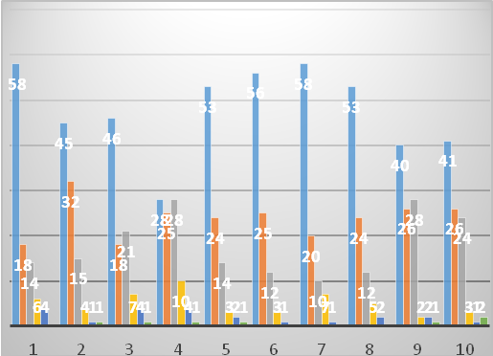 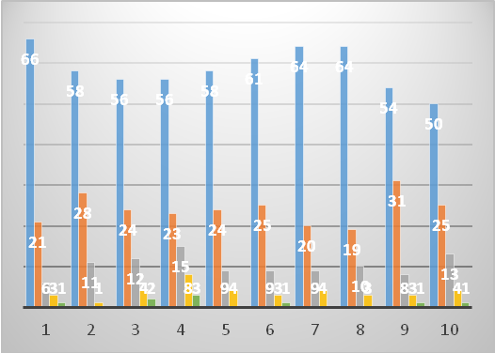

I put the two graphs side by side to show that the perception of the respondents is almost the same! With a slight plus regarding the future.

The participants were then asked if their VET teachers and VET trainers should support their students with digitisation to foster their learning processes. 65 participants (72%) replied Yes, 19 participants (21%) replied probably Yes, 5 participants (6%) replied probably No and 1 participants (1%) replied No.

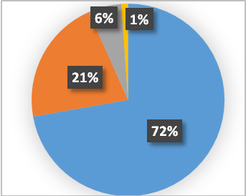

**Opportunities and Challenges**

Finally, we asked our participants what they believed the opportunities of digitisation and Industry 4.0 are. Most of respondents said that, using digitization, all the sectors (industrial, educational, social, etc) will have an unlimited potential of growing.

And when asked what are the challenges of digitisation and Industry 4.0, one of the main answers was the level of preparation for change (including here: education, the degree of acceptance of robots in daily life, collaboration). And also the data protection.

# Conclusion

There are many things to do in Romania, regarding digitisation and Industry 4.0. The majority of the participants has minimum information about this two notions, but everybody agree that there are necessary!