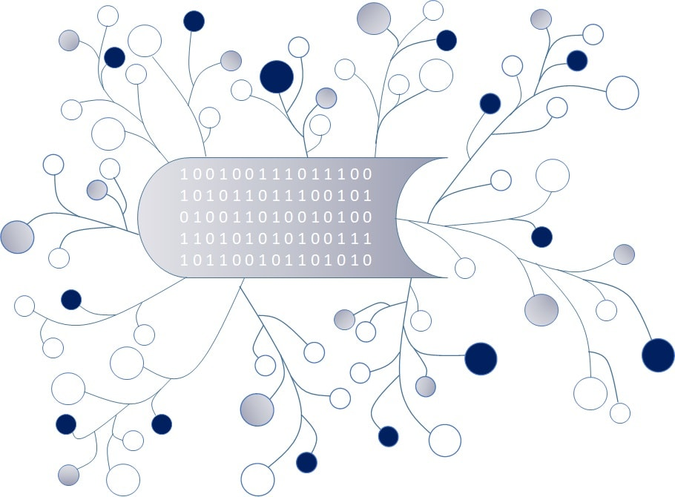
DigI-VET
Fostering Digitization and Industry 4.0 in vocational education

2018-1-DE02-KA202-005145

DigI-VET Classroom Material

November 2020
UPB – Jennifer Schneider

Project Title DigI-VET

Reference Number 2018-1-DE02-KA202-005145

Digitisation?! What does it mean?

Our life is changing fast even the digitisation has become a fundamental part of our daily work and private business. But, what does digitisation means for VET? The following, general definition parts for digitisation shows a great overview of main parts of digitisation.

Reasons for Digitisation:
Digitised information is easier to store, access and transmit, and digitization is used by a number of consumer electronic devices.

Technopedia (2019): Digitization. On the internet: https://www.techopedia.com/definition/6846/digitization [Jan.; 2020]

Tasks:

- Write down an own definition of Digitisation with focus on the field of vocational education and training:
Digitisation in VET means …

- Please think on the main aspects Digitisation should focus on:
Digitsation should focus on… | … because…

- Five different examples of digitisation which you know or heard about:

1.
2.
3.
4.
5.

