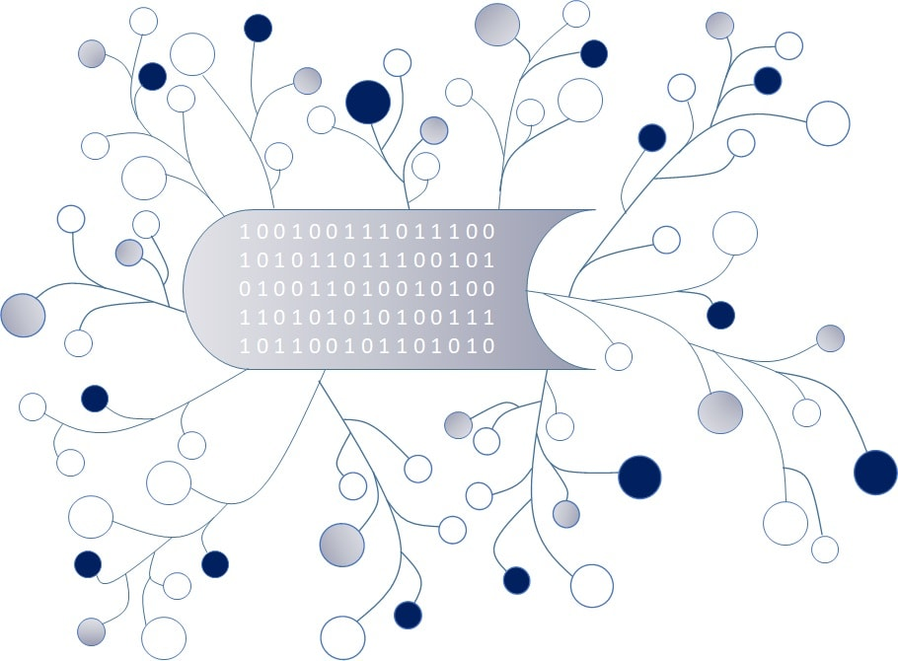
DigI-VET
Fostering Digitization and Industry 4.0 in vocational education

2018-1-DE02-KA202-005145

DigI-VET Classroom Material

Project Title DigI-VET

Reference Number 2018-1-DE02-KA202-005145

Industry 4.0 – What is it?

Industry 4.0 refers to the intelligent networking of machines and processes for industry and describes and fundamental process of innovation and transformation in industrial production. To use this intelligent networking companies have the opportunity to use many different ways like:
- “Flexible production: In manufacturing a product, many companies are involved in a step by step process to develop a product. In being digitally networked, these steps can be better coordinated and the machine load better planned.
- Convertible factory: Future production lines can be built in modules and be quickly assembled for tasks. Productivity and efficiency would be improved; individualized products can be produced in small quantities at affordable prices.
- Customer-oriented solutions: Consumers and producers will move closer together. The customers themselves could design products according to their wishes—for example, sneakers designed and tailored to the customer’s unique foot shape. At the same time, smart products that are already being delivered and in use can send data to the manufacturer. With this usage data, the manufacturer can improve his or her products and offer the customer novel services.
- Optimised logistics: Algorithms can calculate ideal delivery routes, machines independently report when they need new material—smart networking enables an optimal flow of goods.
- Use of data: Data on the production process and the condition of a product will be combined and analysed. Data analysis provides guidance on how to make a product more efficiently. More importantly, it's the foundation for completely new business models and services. For example, lift manufacturers can offer their customers "predictive maintenance": elevators equipped with sensors that continuously send data about their condition. Product wear would be detected and corrected before it leads to an elevator system failure.
- Resource-efficient circular economy: The entire life cycle of a product can be considered with the support of data. The design phase would already be able to determine which materials can be recycled.”

Tasks:

- Research Task:
Please have a closer look on the internet. Can you find 4 companies which use different ways of intelligent networking?
Please name and describe in (1-2 sentences) the company aims/ products:

Company 1:
Company 2:
Company 3:
Company 4:

2. Please compare two companies and their Industry strategies.
What are the similarities? What are the differences?

Company name xx  Vs.  Company name xy | What are the similarities? | What are the differences?
Company name 1
Vs.
Company name 2
Company name 3
Vs.
Company name 4

3. Please create a poster with your results and present it to your classmate.

Federal Ministry for Economic Affiars and Energy (2020): Retrieved from the Internet: https://www.plattform-i40.de/PI40/Navigation/EN/Industrie40/WhatIsIndustrie40/what-is-industrie40.html; https://www.plattform-i40.de/PI40/Redaktion/EN/Standardartikel/vision.html, Access date: 14.07.2021.
Federal Ministry for Economic Affairs and Energy ; Federal Ministry of Education and Research (2020): Retrieved from the Internet: https://www.plattform-i40.de/PI40/Navigation/EN/Industrie40/WhatIsIndustrie40/what-is-industrie40.html, Access date: 14.07.2021.

