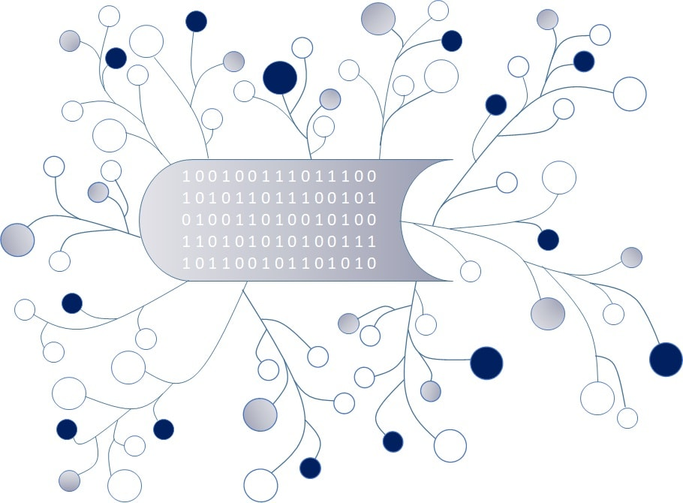
DigI-VET
Fostering Digitization and Industry 4.0 in vocational education

2018-1-DE02-KA202-005145

DigI-VET Classroom Material

November 2020
UPB – Jennifer Schneider

Project Title DigI-VET

Reference Number 2018-1-DE02-KA202-005145

Current Status and future developments
Internet of Things

The Internet of Things can be defined as a network of physical objects. One common definition give the authors Patel and Patel in the year 2016:
„[…] IoT is a global infrastructure for the information society, enabling advanced services by interconnecting (physical and virtual) things based on existing and evolving interoperable information and communication technologies.“ Patel, K. / Patel, S. (2016).

I Task:
Please have a closer look on the internet and answer the following questions:
How can Internet of Things change your daily life? Think of your daily routines and technologies which improve your life!

What are personal benefits of the Internet of Things?

II Task
- Please create a Pro and Contra list of the advantages and disadvantages of the Internet of Things for businesses.
- Make a ranking of the wickedest and best advantages of the Internet of Things for businesses. Please describe in view sentences your decisions.
- Please present your results to your partner. What results are similar, where are differences?

Results:
- Pro and Contra List

- New ranking of the Pro and Contra List

Please describe your decisions:

