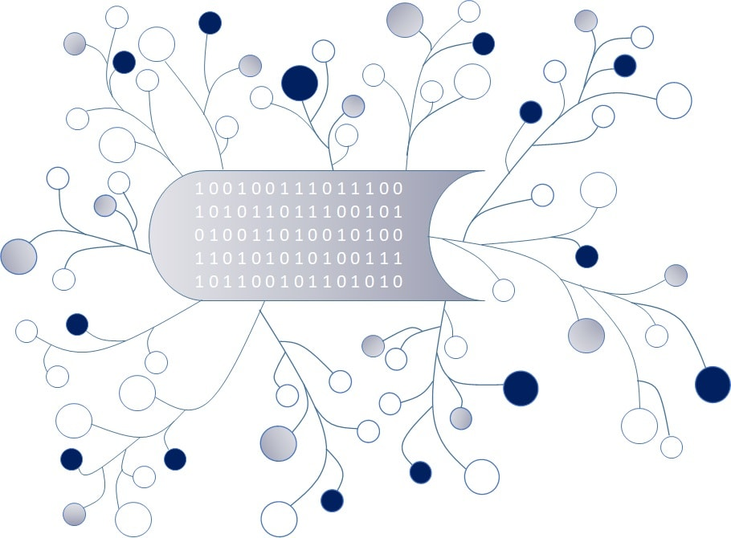

DigI-VET
Fostering Digitization and Industry 4.0 in vocational education

2018-1-DE02-KA202-005145

DigI-VET Classroom Material

Project Title DigI-VET

Reference Number 2018-1-DE02-KA202-005145

Digitisation?! What does it mean?

Digitisation is crucial in todays European life. But, what does digitisation mean?
Read the following definition carefully and try to get an idea of similarities and differences and deal with the tasks on the next page.

What does Digitization mean?
“Digitization is the process of converting analog signals or information of any form into a digital format that can be understood by computer systems or electronic devices. The term is used when converting information, like text, images or voices and sounds, into binary code. Digitized information is easier to store, access and transmit, and digitization is used by a number of consumer electronic devices.”
Technopedia (2019): Digitization. On the internet: https://www.techopedia.com/definition/6846/digitization [03.09.2019]

Difference between Digitization, Digitalization and Digital Transformation

“Digital transformation: Taking advantage of digitalization to create completely new business concepts
Digitalization: Making digitized information work for you
Digitization: Transitioning from analog to digital”
Irniger, Anna (2017): Difference between Digitization, Digitalization and Digital Transformation. On the internet: https://www.coresystems.net/blog/difference-between-digitization-digitalization-and-digital-transformation [03.09.2019]

Digital Transformation

“There are two distinct aspects of digital transformation in the above outlined meaning:
A digital transformation can either focus on technology, in which case we are talking about process & systems transformation.
Or it canfocus on the people within an organization, in which case we are talking about a transformation of culture.“
Sedlacek, Jan (2018): What does digitization really mean? – A framework for practitioners. On the internet: https://stryber.com/digitization-framework/ [03.09.2019]

Tasks:

- Write down an own definition of Digitisation and do some research on the internet about it:
Digitisation means …

- Compare the three definitions provided on the first page and write down similarities and differences in the table below:
similarities | differences

- Give ten different examples of digitisation which you know or heard about:

1.
2.
3.
4.
5.
6.
7.
8.
9.
10.

