DigI-VET
Fostering Digitization and Industry 4.0 in vocational education

2018-1-DE02-KA202-005145

First Competence Profile and Skill Set

November 2019
UPB – Marc Beutner

Project Title DigI-VET

Reference Number 2018-1-DE02-KA202-005145

The DigI-VET
Competence Profile
and skill set for digitization and Industry 4.0(LOM)

Prof. Dr. Marc Beutner, University of Paderborn (UPB), Germany

After the first research and assessments feedback the partners of DigI-VET are already able to provide a first idea on the necessary competences and skill which should be addressed to deal with the topics of digitization and Industry 4.0.

This approach will be specified during the process of the DigI-VET project when more feedback could be gathered and the final analysis of the research work is done.

First DigI-VET Competence Profile:

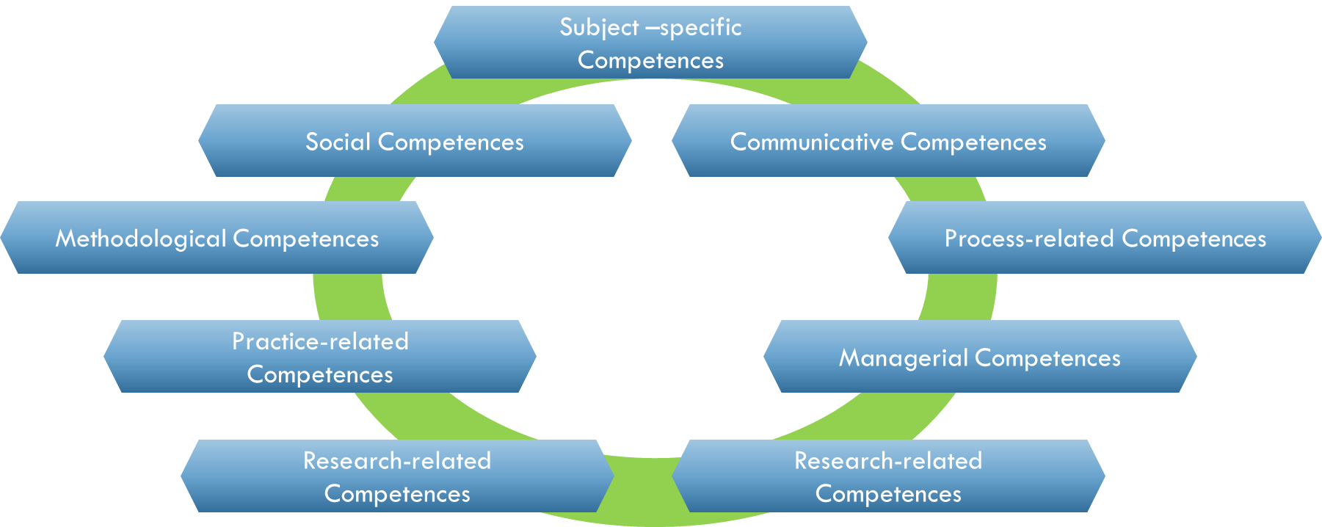

First DigI-VET skill set:

Basic IT skills
Deep IT skills
Technical skills
Organisational skills
Applying theoretical knowledge
Self-awareness and self-management
Leadership skills
Team working skills
Planning skills
Implementation skills
Evaluation skills
Implementation skills
Ethical skills
Self-awareness and self-management skills
Problem solving skills
Decision Making skills
Data analysis skills
Flexibility
Patience

